 |  | International Telecommunication Union
 |  | ITU-T | Technical Report
 |  | TELECOMMUNICATION  STANDARDIZATION SECTOR  OF ITU |  | (24 November 2021)
ITU-T Focus Group on Quantum Information
Technology for Networks (FG QIT4N)
FG QIT4N D2.4
Quantum key distribution network transport technologies
FOREWORD
The International Telecommunication Union (ITU) is the United Nations specialized agency in the field of telecommunications, information and communication technologies (ICTs). The ITU Telecommunication Standardization Sector (ITU-T) is a permanent organ of ITU. ITU-T is responsible for studying technical, operating and tariff questions and issuing Recommendations on them with a view to standardizing telecommunications on a worldwide basis.
Quantum information technology (QIT) is a class of emerging technology that improves information processing capability by harnessing principles of quantum mechanics which is expected to have a profound impact to ICT networks.
The ITU Telecommunication Standardization Advisory Group established the ITU-T Focus Group on Quantum Information Technology for Networks (FG QIT4N) in September 2019 to provide a collaborative platform to study the pre-standardization aspects of QITs for ICT networks.
The procedures for establishment of focus groups are defined in Recommendation ITU-T A.7.
Deliverables of focus groups can take the form of technical reports, specifications, etc., and aim to provide material for consideration by the parent group in its standardization activities. Deliverables of focus groups are not ITU-T Recommendations.
FG QIT4N concluded and adopted all its Deliverables as technical reports on 24 November 2021.
Number | Title
FG QIT4N D1.1 | QIT4N terminology: Network aspects of QITs
FG QIT4N D1.2 | QIT4N use cases: Network aspects of QITs
FG QIT4N D1.4 | Standardization outlook and technology maturity: Network aspects of QITs
FG QIT4N D2.1 | QIT4N terminology: QKDN
FG QIT4N D2.2 | QIT4N use cases: QKDN
FG QIT4N D2.3 | QKDN protocols: Quantum layer
FG QIT4N D2.3 | QKDN protocols: Key management layer, QKDN control layer and QKDN management layer
FG QIT4N D2.4 | QKDN transport technologies
FG QIT4N D2.5 | QKDN standardization outlook and technology maturity
The FG QIT4N Deliverables are available on the ITU webpage, at https://www.itu.int/en/ITU-T/focusgroups/qit4n/Pages/default.aspx.
For more information about FG QIT4N and its deliverables, please contact tsbfgqit4n@itu.int.

© ITU 2022
All rights reserved. No part of this publication may be reproduced, by any means whatsoever, without the prior written permission of ITU.
Technical Report FG QIT4N D2.4
Quantum key distribution network transport technologies
Summary
This technical report is a deliverable of the ITU-T Focus Group on Quantum Information Technology for Networks (FG QIT4N) which discusses QKDN transport technologies such as transport system components, technical solutions, the typical scenarios of the co-existence of quantum and classical signals in a common fibre (CEQC). Analysis about the impact of the classic optical light on the quantum signals is given. Furthermore, some CEQC schemes are shown in the document, both for DV-QKD system and CV-QKD.
Note
This is an informative ITU-T publication. Mandatory provisions, such as those found in ITU-T Recommendations, are outside the scope of this publication. This publication should only be referenced bibliographically in ITU-T Recommendations.
Keywords
QKD; quantum key distribution; quantum key distribution network; transport technologies

Chief editor: | Yalin Li  QuantumCTek Co. Ltd  China | Email: yalin.li@quantum-info.com
Editors: | Chunxu Zhao  China Unicom  China | Email: zhaocx62@chinaunicom.cn
 | Ming Cheng  China Telecom  China | Email: chengm2@chinatelecom.cn
 | Junsen Lai  China Academy of Information and Communications Technology (CAICT)  China | Email: laijunsen@caict.ac.cn
 | Yingming Zhou  Shanghai XT Quantech Co. Ltd  China | Email: zhouyingming@xtquantech.com
 | Yi Qian  China Information and Communication Technologies Group Corporation (CICT) China | Email: qianyi@wri.com.cn

Acknowledgments
The editors express their appreciation to all the contributors of this report and all participants of Working Group 2 of the Focus Group on Quantum Information Technology for Networks (FG QIT4N) for their invaluable inputs, thorough review and all comments provided during the development of this report.

Table of Contents
Page
1 Scope 1
2 References 1
3 Terms and definitions 1
3.1 Terms defined elsewhere 1
4 Abbreviations and acronyms 1
5 Overview of QKDN transport technologies 1
6 QKD systems 5
6.1 DV-QKD system 5
6.2 CV-QKD systems 11
6.3 Passive optical components for QKD link 15
7 CEQC for QKD systems 16
7.1 State-of-the-art on CEQC 16
7.2 CEQC scenarios 20
7.3 Impact of classical light for QKD 23
7.4 CEQC schemes for DV-QKD systems 24
7.5 CEQC schemes for CV-QKD systems with G.698.4 system 28
8 Conclusions 30
Appendix I – Experimental results 31
I.1 Experimental results about the impact of classical light on QKD system 31
I.2 Experimental results of the CEQC Systems of DV-QKD 34
I.3 Experimental results of the CEQC schemes of CV-QKD with G.698.4 38
Bibliography 41

Technical Report ITU-T FG QIT4N D2.4
Quantum key distribution network transport technologies

1 Scope
This Technical Report covers studies of QKDN transport technologies such as transport system components, technical solutions, scenarios and schemes for co-existence of quantum and classical signals in a common optical fibre (abbreviated as CEQC in this report). The studies are categorized into two parts: DV-QKD (Discrete-Variable) and CV-QKD (Continuous-Variable).

2 References
[ITU-T G.698.4] Recommendation ITU-T G.698.4 (2018), Multichannel bidirectional DWDM applications with port agnostic single-channel optical interfaces.

3 Definitions

3.1 Terms defined elsewhere
This Technical Report uses QKDN related terms in [b-QIT4N D2.1].

4 Abbreviations and acronyms
This Technical Report uses the following abbreviations and acronyms:
CEQC Co-existence of quantum and classical signals in a common optical fibre
CV-QKD Continuous-Variable QKD
CWDM Coarse Wavelength Division Multiplexing
DV-QKD Discrete-Variable QKD
DWDM Dense Wavelength Division Multiplexing
OADM Optical Add-Drop Multiplexer
OD/OM Optical DeMux/Mux
QKD Quantum Key Distribution
QKDN QKD Network
QRNG Quantum Random Number Generator
TDM Time Division Multiplexing
WDM Wavelength Division Multiplexing

5 Overview of QKDN transport technologies
As the world embraced digitalization, information became by far the most important and valuable global resource in the modern world. Various types of data need to be protected from hackers and malicious activities; the importance of information technology security thus continues to increase with more organizations looking to the cloud to manage everyday operations and store sensitive data. Currently, and in the future, advancements on quantum sensor networks, quantum computing networks and quantum communication networks are and will continue to develop at an extremely fast pace and quantum transport technologies are emerging as a very important and necessary requirement. Future hyperscale data centres and exascale computers may increasingly incorporate quantum computers and communication nodes to complement their capabilities such as the provisioning of "quantum as a service".
Currently, the most commonly used QKDN technology is based on the advantages of quantum effects and quantum communications networks are based on point-to-point quantum key distribution links, as illustrated in Figure 1.
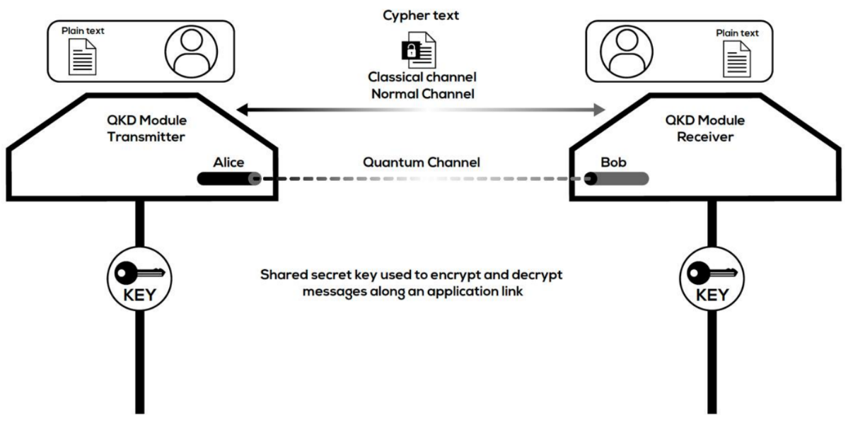
Figure 1 – Point-to-point QKD link
The majority of QKDN could be categorized into either metro and trunk networks, see Figure 2, which are usually linked by optical fibres, or long-haul networks which are usually linked by free-space, i.e., satellites, see Figure 3 [b-Lee].
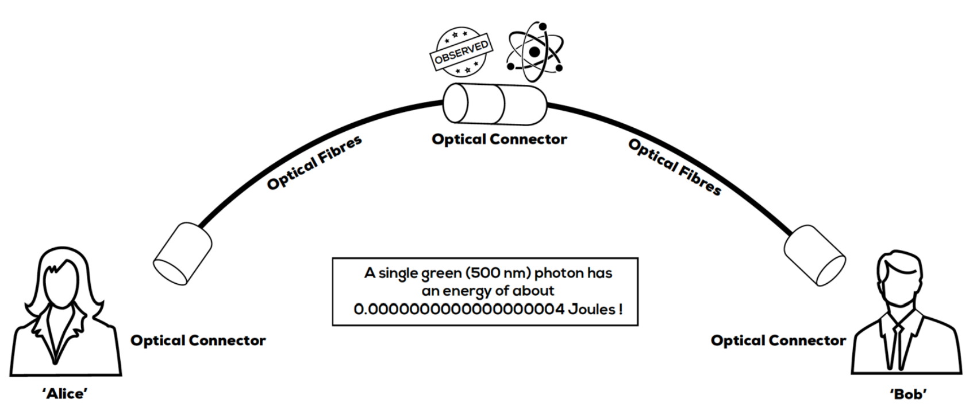
Figure 2 – Metro & trunk quantum networks based on optical fibres
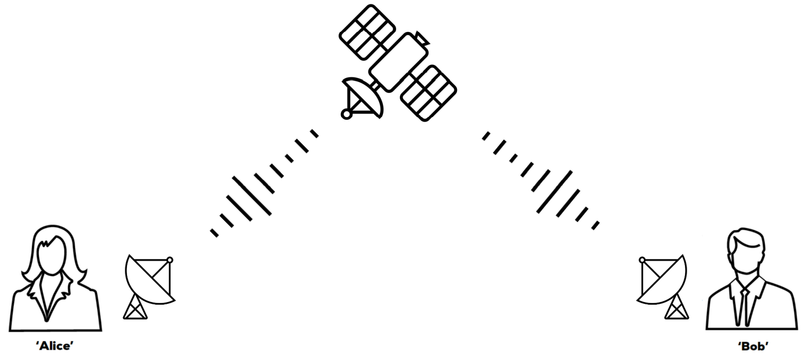
Figure 3 – Long-haul quantum networks based on satellites
A typical fibre based QKD network is analogous to an optical communication network, in which the network is divided into 3 Layers, i.e., access layer, aggregation & core layer, and backbone layer, see Figure 4.
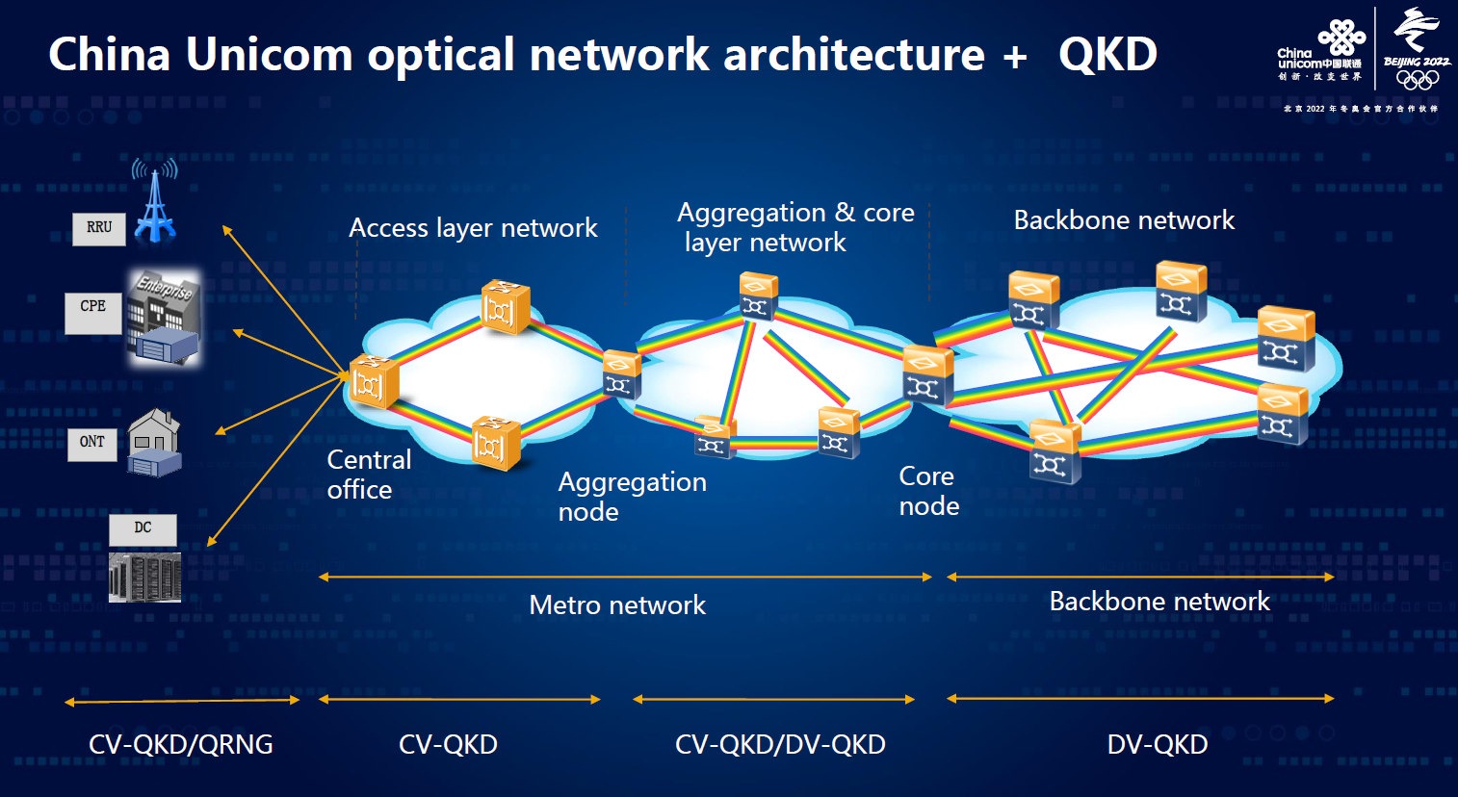
Figure 4 – Optical network with QKD [b-Zhao]
In the access layer, there will be large amount of end-user QKD devices to be deployed. Thus, low device cost and a cost-effective way of deploying QKD devices arise necessary.
NOTE – Based on the commercial maturity, only prepare-and-measurement type of QKD (such as BB84, GG02, COW, DPS, etc.) are considered in this document.
In QKDN access network, there are several typical topologies, as shown in Figure 5.
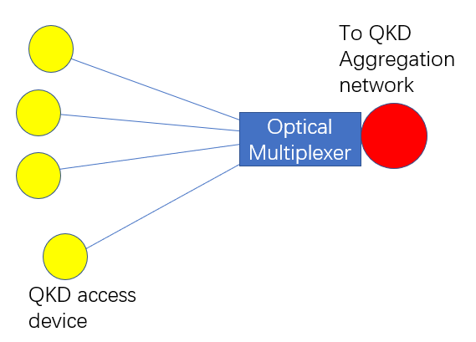 | 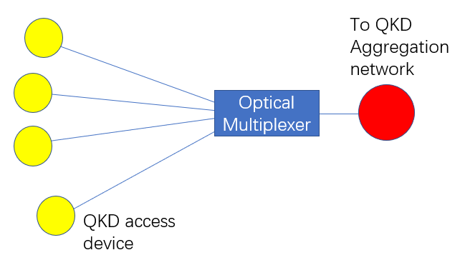 | 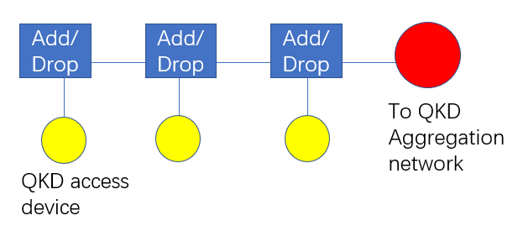 | 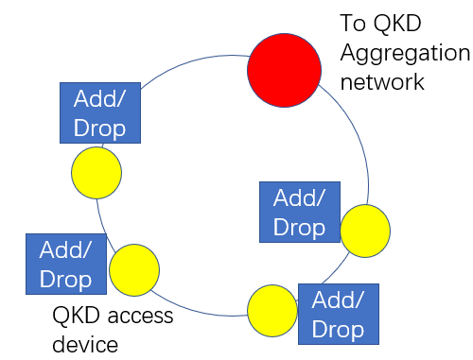
a) Multi-point to one point topology | b) Tree topology | c) Bus topology | d) Ring topology
Figure 5 – Typical topologies for QKD access network
a) Multi-point to one point: Multiple QKD transmitters (Tx) share a common QKD receiver (Rx) – reversed if QKD Rx is cheaper than QKD Tx – via an optical multiplexer which is deployed with a shared QKD Rx (or Tx if reversed) within the same place, see Figure 6. The optical multiplexer and corresponding multiplexed degree of freedom could be an optical switch (TDM based), optical power splitter (TDM based) or DWDM (WDM based).
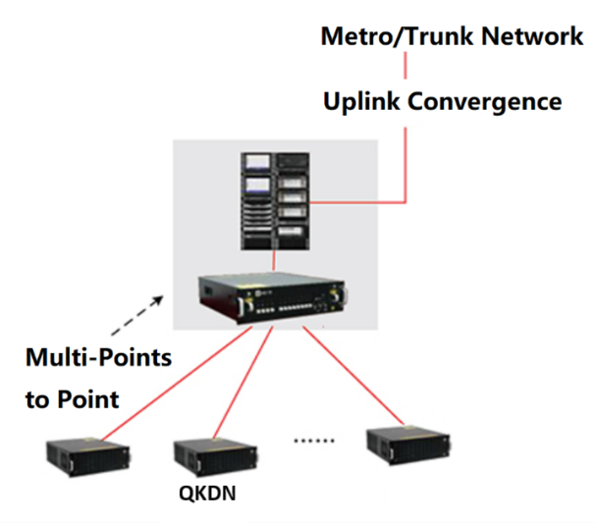
Figure 6 – Multi-point to one point deployment of QKD via optical switch
b) Tree-type structure: Multiple QKD Tx share a common QKD Rx (reversed if QKD Rx is cheaper than QKD Tx) via an optical multiplexer which is deployed somewhere in the transmission line, not attached to the shared QKD Rx (Tx). In this case, the optical multiplexer is always a passive device (needs no electric power supply), similar to existing passive optical network (PON) which is dedicated for optical access network. The optical multiplexer and corresponding multiplexed degree of freedom can be optical power splitter (TDM based, see Figure 7 (a) or DWDM (WDM based or WDM+TDM based, see Figure 7 (b).
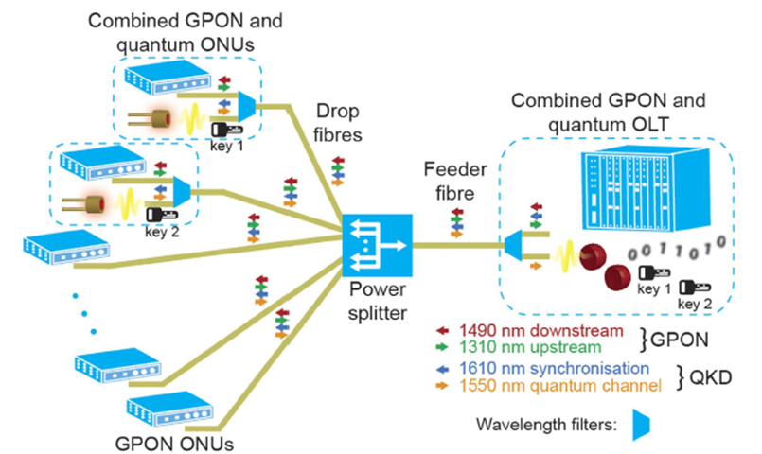 | 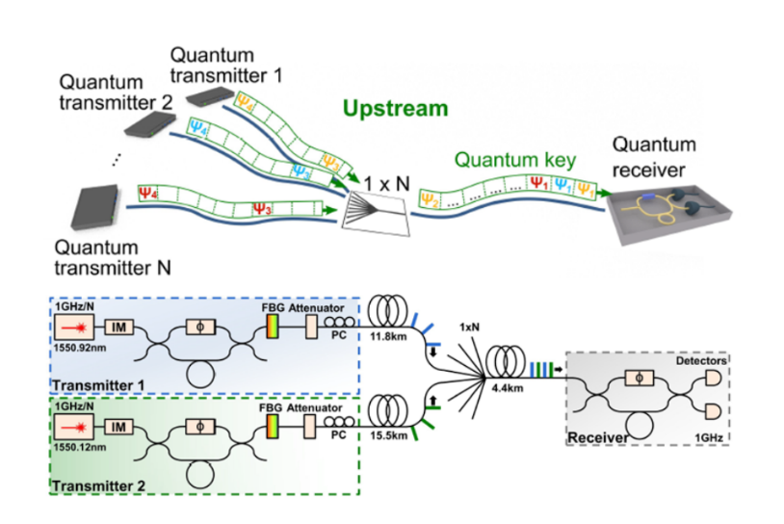
(a) via optical power splitter [b-Fröhlich-1] | (b) via DWDM [b-Fröhlich-2]
Figure 7 – Tree type QKD access network
c) Bus-type structure: Multiple QKD Tx share a common QKD Rx (reversed if QKD Rx is cheaper than QKD Tx) via Add/Drop optical multiplexer in a drop-line type topology. The Add/Drop optical multiplexer and corresponding multiplexed degree of freedom, can be an optical switch (TDM based), optical power splitter (TDM based) or DWDM (WDM based).
d) Ring-type structure: Multiple QKD Tx share a common QKD Rx (reversed versa if QKD Rx is cheaper than QKD Tx) via Add/Drop optical multiplexer in a ring type topology. The Add/Drop optical multiplexer and corresponding multiplexed degree of freedom, can be an optical switch (TDM based), optical power splitter (TDM based) or DWDM (WDM based).
This Technical Report discusses QKDN transport technologies such as transport system components, technical solutions and the typical CEQC scenarios. The impact of the classical optical light on the quantum signals is also analysed and the CEQC schemes and evaluation results for DV-QKD and CV-QKD systems are provided.

6 QKD systems
The security of a QKD system is often related to its implementation which is composed of three parts: source, channel, and detection. Photons are most widely used for communication due to their robustness against decoherence due to the noisy environment and fast traveling speed ‎0.

6.1 DV-QKD system

6.1.1 Decoy-state BB84 QKD protocol
The BB84 protocol was the first QKD protocol in history and was proposed by Charles Henry Bennett and Gilles Brassard in 1984 [b-Bennett]. Studies on the BB84 protocol are the most abundant and in-depth among all the QKD protocols which ensures its high theoretical security.
The original BB84 protocol was supposed to use an ideal single photon source, however, as this is not practical yet, experimenters can only use a semiconductor laser to prepare weak coherent state light to approximate the ideal single photon source. Weak coherent state light contains multiple photons with a certain probability and is threatened by photon number splitting (PNS) attack. Therefore, the secure key rate for the BB84 protocol is greatly limited.
Decoy state technology solved this problem by randomly replacing decoy lights of different intensities in weak coherent state light to monitor channel variation and the impact of eavesdroppers. When combined with decoy state technology, even if a weak coherent state light source is used, the security of the BB84 protocol (i.e., decoy-state BB84 protocol) can almost be the same as using an ideal single photon source. Therefore, in the laboratory and engineering practice, the decoy-state BB84 protocol has been widely adopted.
The decoy-state BB84 protocol flowchart shown in Figure 8 mainly consists of quantum state preparation, information encoding, quantum state transmission, quantum state measurement, sifting error correction and privacy amplification.
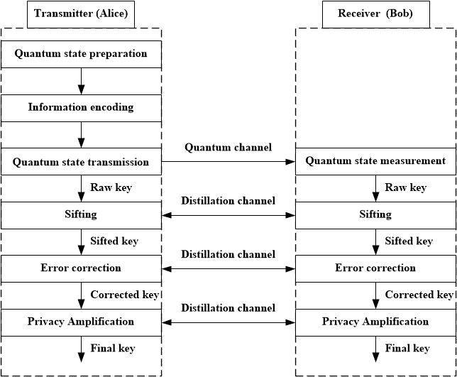
Figure 8 – Flowchart of decoy-state BB84 protocol
Quantum state preparation is the process in which the QKD transmitter prepares quantum states as carriers of key information. It mainly consists of bases selection, states preparation, and pulse intensity modulation (decoy state modulation). The QKD transmitter and receiver select two sets of orthogonal bases (encoding basis for Tx and measurement basis for Rx) that are conjugate to each other in the two-dimensional Hilbert space. Each set of bases contains two orthogonal quantum states therefore, four quantum states will be prepared at the transmitter. The short pulse emitted by the weak coherent pulse source is used as the information carrier and is combined with intensity modulation to achieve the decoy state. Taking the commonly used three-intensity decoy-state protocol as an example, the quantum state pulse can be modulated into three different intensities which can be used as the signal state, decoy state and vacuum state, respectively.
Information encoding is the process in which the transmitter randomly loads the quantum state used to encode the key information on the corresponding pulse. According to the random number sequence, the quantum states that need to be encoded on the light pulse are first determined through the correspondence between the binary bits (0, 1) and the quantum states. Then, based on the determined quantum state information, the quantum state used to encode the key information is modulated onto the corresponding pulse while the binary bits information loaded on the quantum state is saved.
Quantum state transmission is the process in which a transmitter sends a quantum state pulse loaded with key information to the receiver through a quantum channel, such as via optical fibre or free space, and the transmitter records the intensity of the emitted pulse and encoded key information. The transmitter also sends synchronization signals to the receiver to support the detection of quantum state signals.
Quantum state measurement realises the receiver's raw key acquisition and consists of two processes of decoding and detection. The receiver first randomly selects a measurement basis to measure the pulses loaded with quantum states from the transmitter then detects the demodulated photon signal in the single photon detectors (SPD) and records these detectors' response to get the raw key.
The post-processing of the BB84 protocol is completed through the exchange of information between the sending and receiving parties in the distillation channel where authentication is used to ensure the consistency and integrity of the exchanged information. Post-processing is composed of:
• Sifting: this is the comparison between the encoding basis used by the transmitter and the measurement basis used by the receiver. Only a key of the same basis used in the transmitter and receiver will be retained to generate the sifted key.
• Error correction: parameter estimation, also known as bit error estimation, which analyses the sifted key to estimate the qubit error rate is first performed. Afterwards, qubit errors in the sifted key at both parties are corrected by using a certain algorithm to obtain a consistent key which is the corrected key.
• Privacy amplification: this refers to a process in which the transmitter and receiver perform mathematical processing on the corrected key to eliminate information that eavesdroppers may have and extract the final key.

6.1.2 DV-QKD system model and reference points
A decoy-state BB84 QKD system generates a shared key that is consistent between the transmitter and receiver based on quantum state preparation, transmission, measurement and post-processing. The system also provides the key output to the key management or user network.
The reference model and interfaces of a typical commercialized decoy-state BB84 system, as shown in Figure 9, is composed of a QKD transmitter and receiver as well as an optional multiplexer/demultiplexer and switch.
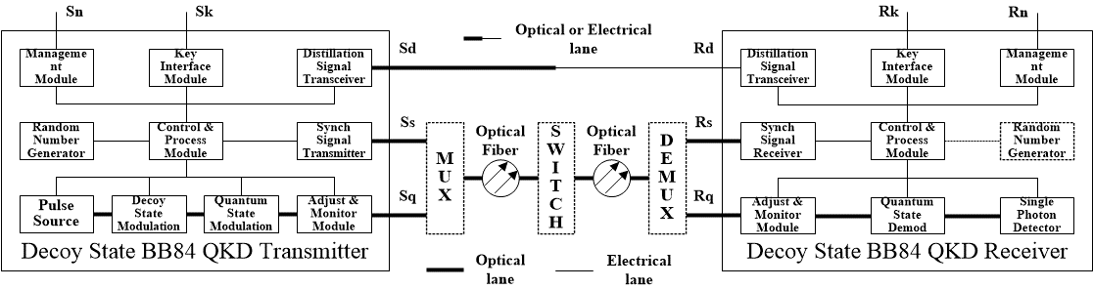
Figure 9 – System model and reference points of decoy-state BB84 system
The QKD transmitter is composed of a:
• pulse source to provide an initial pulse of the quantum state signal;
• decoy state modulation module to implement decoy state modulation (which can also be integrated with the pulse source);
• quantum state modulation module to implement the quantum state encoding and modulation function;
• random number generator to provide control for decoy state modulation and quantum state modulation;
• synchronization signal transmitter to realise the generation and output of synchronization optical signal.
The QKD receiver is composed of a:
• quantum state demodulation module to measure and decode the quantum state signal;
• SPDs to detect the demodulated photon signal;
• random number generator (optional) to provide control for the quantum state demodulation in the active measurement basis selection mode;
• synchronization signal receiver module to detect and recover synchronization information to support photon detection and post-processing.
The QKD transmitter and receiver both have a:
• quantum channel adjust and monitor module to implement power control or abnormality monitoring;
• control and process module to implement system control and protocol post-processing functions;
• distillation signal transceiver module to exchange information between the two parties, which can be configured as optical or electrical interface;
• key interface module to provide key output; management module to provide the management and maintenance interface.
The most important performance metric of a decoy-state BB84 QKD system is the key rate, which is closely related to quantum channel loss. Typically, the average key rate of a commercial decoy-state BB84 QKD system is in the range of several kbit/s to tens of kbit/s, and the field network fibre transmission reach is usually less than 100 km. The key generated from the QKD transmitter and receiver should be exactly the same and its randomness should meet relevant requirements.
The multiplexer/demultiplexer can either be configured in the QKD link as stand-alone equipment or be integrated into a QKD transmitter and receiver to realise the wavelength division multiplexing (WDM) function of the quantum state signal and other optical signals including, but not limited to, the synchronization and distillation signals. The optical lane switch can also be configured in the QKD link to realise the time division multiplexing (TDM) function of the quantum state signal and other optical signals.
Due to its single photon characteristic, the quantum state signal cannot be optically amplified by an erbium-doped fibre amplifier (EDFA). Additionally, in the CEQC scenario, the scattered noise introduced in the fibre by other optical signals or spontaneous emission noise from an EDFA could seriously affect the effectiveness of single photon detection which needs well-designed wavelength allocation and high-performance spectrum filtering.
In contrast to the optical transport system which can guarantee a certain level of bit rate, the key rate of a decoy-state BB84 QKD system could fluctuate or, even worse, have a short period of interruption due to the system self-calibration or quantum channel feedback compensation. Moreover, due to the existence of the single photon detector and other delicate optical components, the environmental robustness of a decoy-state BB84 QKD system is not as good as optical transport systems. Drastic changes in the ambient temperature will probably lead to large fluctuations in the key rate. Sacrificing system margin and robustness for eavesdropping resistance might be, inevitably, the reason for the frangibility of the decoy-state BB84 QKD system.

6.1.3 DV-QKD system key components
A typical DV-QKD system is comprised of the following key components:
a) Encoding and decoding: Different encoding and decoding methods are reflected for source, channel and detection. For discrete-variable QKD schemes, Alice needs to figure out an efficient method to encode qubits (or qudits) in the quantum states. Accordingly, Bob needs to develop an efficient method to read out the quantum information encoded by Alice [b-Xu]. Some widely applied methods include polarization encoding, phase encoding and time-bin phase encoding.
b) Photon sources: For most prepare-and-measure (P&M) QKD protocols, a single-photon source is preferred. However, it is experimentally challenging to realise a high quality and high performance single-photon source. As a result, weak coherent-state source, thermal source, heralded single-photon source and entangled-photon source are used in realistic QKD systems. Among them, the weak coherent-state source is the most widely employed in QKD which can be easily realised by attenuating laser lights [b-Xu].
c) Channel: Theoretically, no assumption is placed on the quantum channel used for QKD. However, in the real-world implementation, the QKD channel is built using mature optical communication technology to enhance the performance of the QKD protocol.
NOTE – There are two widely adopted channels for QKD i.e., fibre and free space and the most common channel used for QKD is commercial optical fibre.
One of the main challenges of adapting commercial classical communication networks infrastructure for QKD is the requisite change to the fundamental performance characteristics. This is attributed to the unique features and restrictions of QKD technologies such as the requirement for point-to-point "quantum" channels that are not only ultra-low loss but also ultra-low reflectance to minimize decoherence i.e., collapse of the wavefunction. For a standard commercial single-mode fibre, losses depend exponentially on the channel distance l as 10^{−αl/10}, where the loss rate α is roughly 0.2 dB/km for a telecommunication wavelength of around 1550 nm.
The free-space channel features some advantages over optical fibre:
• there are several atmospheric transmission windows, including 780–850 and 1520–1600 nm, which have a low loss and an attenuation less than 0.1 dB/km in clear weather. The attenuation is negligible even in outer space (i.e., above Earth's atmosphere) which enables long-distance QKD of over 1000 km between ground and satellite;
• the decoherence of polarization or of any other degree of freedom is practically negligible.
However, there are also some drawbacks to free space. For instance, weather conditions influence the loss of free space heavily and the effective apertures of the sending and receiving telescopes, influenced by alignment, movements and atmospheric turbulence, contribute coupling losses and affect the performance of free space QKD [b-Xu].
d) Detection: For DV-QKD schemes, single-photon detection is realised by threshold detectors that can distinguish the vacuum (zero photon) from either single-photon or multiphoton cases only. However, some imperfections may exist in the SPD that will affect the performance of QKD systems:
• the detector efficiency η is not 100% meaning that some non-vacuum signals will not cause a click on the SPD;
• a dark count factor, pd, exists which means that some vacuum signals will incorrectly cause a click.
The measurement model is based on the threshold SPDs mentioned previously. For the single-photon subspace, the detection here can be regarded as an X/Y–basis qubit measurement. However, there is a multiphoton component in the final signal and the behaviour of the measurement device differs from the required Z-basis and X-basis measurements in DV-QKD [b-Xu]. See Table 1 for SPD parameters and the performance of different SPD technologies.
e) Postprocessing: Postprocessing is a procedure for Alice and Bob to distil a secure key from the raw data measured in quantum transmission with the help of public discussions. The flow chart of QKD postprocessing is shown in Figure 10.
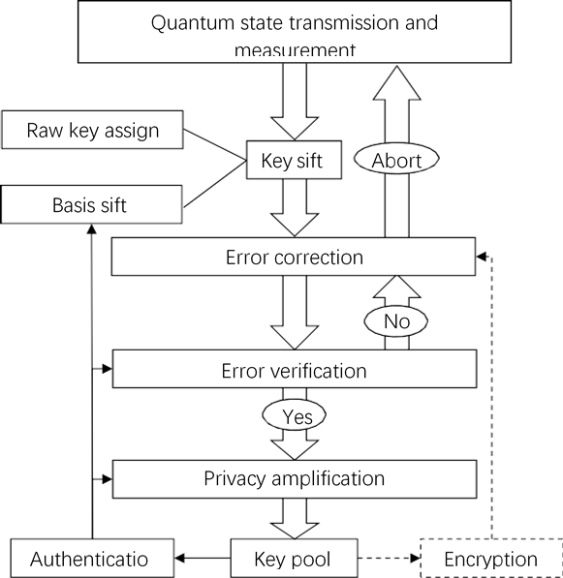
Figure 10 – Flowchart of data postprocessing procedures [b-Xu]

6.1.4 Single photon detector for DV-QKD system
SPDs play a vital role in QKD that carries out discrete-variable protocols (BB84, BBM92, E91) [b-Scarani] and distributed-phase-reference protocols (coherent one way, differential phase shift) [b-Scarani]‎. Their performance is quantified by the following typical metrics [b-Hadfield] and [b-Zhang]:
• Detection efficiency: defined as the probability of a detector generating a response signal (conventionally called "click") from an incoming photon (or attenuated weak pulse which has mean photon number < 1 during each time interval).
• Dead time: the time interval that the SPD is unable to register a photon if the last detection event successfully occurs.
• Maximum counting rate: the maximum rate at which the SPD can generate the response signal. At the maximum rate or beyond the maximum rate condition, the SPD is "saturated".
• Dark count: defined as the situation that the SPD generates a false "click" even there is no incoming photon.
• Gating frequency: for some types of SPDs, an external or internal trigger signal is used to turn up its voltage above the breakdown voltage, thus turned into the "detecting mode", after which the detector is forced to quench. The frequency of the trigger signal is defined as the gating frequency.
• Gating window width: the effective detection time window of gated SPD – a narrow gating window width helps to reduce the dark count rate and background noise while the pulse-width is comparable to the gating window width.
• Free running: the operating mode in which the SPD can continuously generate detection events once the quench is done. This is applicable for time-bin encoded QKD.
• After pulse: the false detection caused by the previous avalanche (in single photon avalanche diode case) or dark count.
• Spectral range: the SPD can respond to incident light which has a certain range of their wavelength, based on its material. For either free-space or fibre-based QKD, the constituent material of the SPD is tailored to the visible spectral range or near-infrared range, respectively.
• Timing jitter: the variation in the time interval between the absorption of a photon and the generation of an output electrical pulse from the detector.
• Photon number resolving: the ability that the detector can tell the numbers of incoming light pulse, other than just generate a binary response consisting of {"No Click", "Click"}. Such kind of a detector is needed to reconstruct the incoming photon number statistics using ensemble measurements. However, for discrete variable and distributed-phase-reference QKD protocols, such ability is not necessary.
Commercially available SPD technologies are introduced as follows:
• Photomultiplier tubes (PMT): This is perhaps the earliest developed technology for single photon detection [b-Morton]. A PMT consists of a vacuum tube with a photocathode and a cascade of dynodes. The incoming photons liberate the electrons through the photoelectric effect. The single or few electron photocurrent is then multiplied by the dynodes – a series of electrodes, each one biased at a greater positive voltage than the one before – producing a macroscopic current pulse. PMT requires operating voltages around the kilovolt-level, which may not be suitable for practical QKD systems.
• Single-photon avalanche photodiodes (SPAD): SPADs are based on avalanche photodiode structure. The diode is reverse-biased above the break-down voltage (known as Geiger mode operation) and the incoming photons generate the carriers which undergo avalanche gain leading to a macroscopic breakdown of the diode junction [b-Haitz]. Finally, the avalanche is stopped via a quenching process [b-Brown] and, depending on the spectral range for different QKD scenarios such as free-space QKD or fibre-based QKD, the material of SPAD could either be silicon or Ge/InGaAs/InP. The Ge/InGaAs/InP material based SPAD has a much higher dark count rate than the silicon SPAD. As a result, typical InGaAs SPADs need to be operated in Geiger mode – the quiescent device is biased beneath the breakdown voltage and only when there is an incoming photon, a short electric pulse (around 1 ns) is applied to the quiescent device, triggering the detection.
• Frequency up-conversion SPDs: Frequency up-conversion single-photon detection schemes aim to convert a telecommunications-wavelength (e.g., 1550 nm, 1310 nm) photon to a shorter wavelength that can be more efficiently detected.
• Superconducting nanowire single-photon detectors (SNSPDs): They have high detection efficiency from visible to infrared spectral range, low dark counts, short dead time and low timing jitter. They operate in the temperature range of 1.5-4 K, well below the superconducting transition temperature of the niobium nitride film. The superconducting nanowire is biased just below its critical current which is the point at which the wire becomes resistive. When a photon hits the wire, a local resistive hotspot is formed, perturbing the current distribution and thus triggering a fast voltage pulse that can then be amplified and measured [b-Gol'tsman]. SNSPDs have various QKD-related applications in which the high detection efficiency, low dark count and nearly non after pulse are desired such as MDI-QKD, TF-QKD and characterization of integrated chip based QKD components.
Table 1 – QKD experiments with different SPD technologies
Technology | Repetition rate | Protocol | Distance (and/or) loss | Key rate (bps) | Detection efficiency | Dark count rate | Dead time | Timing  jitter | After  pulse | Year | Ref
SPAD | 2.5 MHz | Decoy-state BB84 | 107 km | 14.5 | 33%,  50% |  | 4us | 100ns |  | 2007 | [b-Rosenberg-1]
SPAD | 1 GHz | Decoy-state BB84 | 100 km | 10.1K | 10% | 6.8e-6 | 2ns |  |  | 2008 | [b-Dixon]
SPAD | 320 MHz | Decoy-state BB84 | 130 km | 0.2K | 10% |  |  |  |  | 2010 | [b-Chen-1]
SPAD | 1 GHz | T12 | 80 km | 120K | 20.5% | 2.1e-5 |  |  | 5.25% | 2013 | [b-Lucamarini]
SPAD | 1 GHz | Decoy-state BB84 | 50 km | 306K | 20% | 2e-6 |  |  | 1.1% | 2018 | [b-Wang]
FUCSPD | 1.27 GHz | SARG | 50 km | 20K | 7% | 200 Hz |  |  | 1% | 2006 | [b-Thew]
SNSPD | 10 MHz | Decoy-state BB84 | 135 km | 0.2 | 0.5% |  | 10ns | 69ps | - | 2009 | [b-Rosenberg-2]
SNSPD | 2.5 GHz | Time Bin  BB84 | 421 km  71.9 dB | 0.25 | 40% ~60% | 0.1 Hz |  | 40ps | - | 2018 | [b-Boaron]
SNSPD | 75 MHz | MDI  Time Bin | 100 km | 14.5 | 46% | 6.4e-8 |  |  | - | 2019 | [b-Liu]
SNSPD |  | TF-QKD | 509 km  ULL fibre | 0.269 |  |  |  |  | - | 2020 | ‎[b-Chen-2]  [b-Liu]
SNSPD | 1 GHz | Chip-Based Transmitter  QKD | 20 km | 329K | 40% | 5e-7 |  |  | - | 2017 | [b-Sibson]

6.2 CV-QKD systems

6.2.1 System modules and reference points
QKD is currently the rigorously proven new information security technology that can guarantee the security of information theory. It can be widely used in many fields such as finance, government, power, energy, etc. Its mainstream technical directions include discrete variable (DV) QKD and continuous variable (CV) QKD.
The CV-QKD scheme usually encodes information on the position and momentum quadrature of quantum states. It has potential advantages such as high bit rate and suitability in co-propagating with classical optical communication links. It is also suitable for photonics integration as CV-QKD systems are similar to coherent optical communication modules. In recent years, CV-QKD has made great theoretical and experimental achievements; one of the most notable achievements is that the gaussian-modulated coherent state (GMCS) scheme (GG02 protocol) has been proven to be secure against collective and coherent attacks.
For the GG02 protocol, the transmitter (Alice) prepares the initial coherent state and encodes two random numbers with independent Gaussian distributions on coherent state. Alice then sends the modulated coherent state to the receiver (Bob) via a quantum channel (either optical fibre or free space). Bob performs homodyne detection on the selected quadrature and obtains the measurement result.
The general configuration of a CV-QKD system is shown in Figure 11.
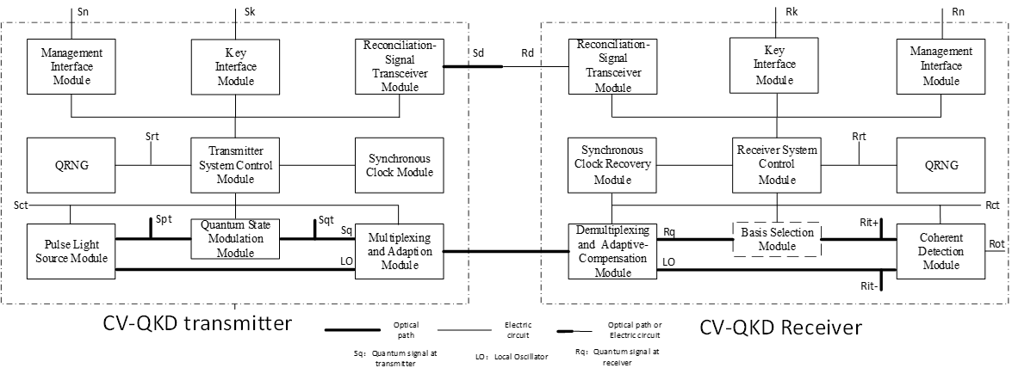
Figure 11 – Reference points for the CV-QKD system
The CV-QKD transmitter is composed of a pulse light source module, quantum state modulation module, multiplexing and adaptation module, random number generator, transmission system control module, synchronous clock module, reconciliation signal transceiver module, management interface and key interface module. The CV-QKD receiver is composed of a demultiplexing and adaptation compensation module, basic selection module, coherent detection module, random number generator, receiving system control module, synchronous clock recovery module, reconciliation signal transceiver module, management interface module and key interface module.
The basic functions of the above modules are as follows:
• Pulse light source module: generates and outputs signal light pulses to carry information and local oscillator light pulses for coherent detection at the receiver.
• Quantum state modulation module: realises signal modulation and controls the attenuation of light intensity.
• Multiplexing and adaptation module: realises multiplexing and simultaneous transmission of the quantum signal light and local oscillator light as well as the signal light for monitoring feedback.
• Transmitter system control module: the control module of the transmitter system mainly controls the work and operation of each module and device of the transmitter system.
• Synchronous clock module: provides a reference clock for the transmitter system.
• Random number generator module: provides the transmitter/receiver with the random numbers needed to implement the CV-QKD protocol, such as modulation, basic selection, and post-processing procedure.
• Management interface module: provides related management interfaces for CV-QKD equipment.
• Key interface module: provides related interfaces for the key output of CV-QKD.
• Reconciliation-signal transceiver module: transmits, receives and processes reconciliation interaction signal for post-processing procedure of CV-QKD.
• Demultiplexing and adaptive compensation module: demultiplexing of the quantum signal light and local oscillator light as well as polarization compensation.
• Basis selection module: implements the measurement basic selection procedure described in the CV-QKD protocol. For balanced heterodyne detection schemes, the basis selection module is not required.
• Synchronous clock recovery module: recovers the clock signal at the transmitter from the received local oscillator reference light and provides the operating reference clock for receiver.
The reference points for the CV-QKD system illustrated in Figure 12 are as follows:
• Spt represents reference point of the pulse light source module
• Sqt represents reference point of the quantum state modulation module
• Sct represents the reference point of the system clock of the QKD transmitter; Rct represents the reference point of the system clock of the QKD receiver
• Srt represents the reference point of the random number generator at the QKD transmitter; Rrt represents the test reference point of the random number generator at the QKD receiver
• Sn indicates the reference point of the QKD management interface module; Rn indicates the reference point of the QKD management interface module
• Sk represents the reference point of key interface module at QKD transmitter; Rk represents the reference point of key interface module at QKD receiver
• Rit (Rit +, Rit-) represents the reference point of the input signal of the coherent detection module at the QKD receiver

6.2.2 CV-QKD technical parameters
The QKD device which mainly consists of two types of devices, i.e., the transmitter end and the receiver, is used to generate shared secret keys between the sender and receiver. The device interface physical channels consist of quantum channels, synchronization channels and reconciliation channels. The main technical parameters of QKD equipment are described in the following subclause.

6.2.2.1 CV-QKD transmitter
a) Pulse light source module: generates coherent pulse signal as the light source for the quantum signal. The main parameters are listed in Table 2.
Table 2 – Parameters of pulse light source
for CV-QKD based on GG02 protocol
Parameter name | Unit
Light Pulse frequency | MHz
Light source intensity | mW
Light source spectrum/wavelength | Hz/nm
Light pulse width | ns
b) Quantum state modulation module: implements information modulation on the quantum state. For the GG02 protocol, this module encodes information on the amplitude and phase of the optical field such that the modulation information follows the Gaussian distribution. The main parameter is the modulation variance $V_{A}$.
c) QRNG module: generates random numbers based on physical processes and meets the relevant certification requirements of the crypto industry as well as supports random number detection of crypto products. The random number generated at the CV-QKD transmitter is used as a control signal for the quantum optical signal modulation. At the transmitter, the random number generation rate is equal to: $\text{2 × data width of DAC × repetition frequency}$.
d) Transmitter system control module: The control module of the transmitter and receiver of the QKD system manages and controls other functional modules in the system. It is required to complete the data processing to share the same secure key between the transmitter and receiver.

6.2.2.2 CV-QKD receiver
a) Basis selection module: this module is optional at the receiver. When Bob performs heterodyne detection, this module is unnecessary, however, when Bob implements homodyne detection, this module is needed. The basis selection module randomly selects the phase angle $θ$ which is either $0$ or $π/2$.
b) QRNG module: generates random numbers based on physical processes and meets the relevant certification requirements of the crypto industry as well as supports random number detection of crypto products. When Bob performs homodyne detection, the random number at the CV-QKD receiver is generated as the control signal for the demodulation of the quantum state optical signal at the basis selection module. Additionally, the random number is used as the input reconciliation signal at the receiver at the post-processing procedure stage.
c) Coherent detection module: CV-QKD performs coherent detection at the receiver and then obtains the measurement results. The main parameters of this module are listed in Table 3.
Table 3 – Parameters of coherent detection module
Parameter name | Unit
Quantum efficiency | –
Common mode rejection ratio | dB
Electronic noise | –
Bandwidth | MHz
d) Reconciliation signal transceiver module: this module realises the two-way transmission of the reconciliation signal at the transmitter and receiver of the CV-QKD system. The reconciliation signal can be used for the post-processing procedure of the QKD protocol and the bandwidth of the reconciliation signal transceiver module should be larger than thousands of megabytes.
The data processing procedure consists of parameter estimation, secret reconciliation and privacy amplification. The main input and output parameters in this module are listed in Table 4.
Table 4 – Data processing performance parameters of
CV-QKD transmitter system control module based on GG02 protocol
Parameter Name | Unit
Shot-Noise Variance ($N_{0}$) | –
Channel Transmission ($T$) | –
Excess Noise ($ε$) | –
Reconciliation Efficiency ($β$) | –
Frame Error Ratio ($FER$) | –
Secure Secret key Rate | bits/s

6.3 Passive optical components for QKD link
One of the main challenges of adapting existing commercial passive optical components manufactured for classical communication networks infrastructure to cater for QKD is the requisite change to the components' fundamental performance characteristics. This is attributed to the fact that QKD transmission has unique features and restrictions, such as the requirement for point-to-point quantum channels, that are not only ultra-low loss but also ultra-low reflectance to minimize decoherence i.e., collapse of the wave function. Since decoherence can be caused by direct measurement or by disruption to the photon propagation due to aberrations (imperfections) in the optical link constructed from passive optical components such as optical fibre, connectors, multiplexers, etc., the chances of transmitting a photon from the transmitter to receiver without or with minimal disruption, absorption or decoherence decreases as the length of any quantum channel increases and also as the quality of the quantum channel decreases. Compromises between performance and commercial viability would need to be considered in selection of the components used to build the QKD link.
Given that the power of a single photon can be of the order of −100 dBm, transmission over longer distances represents a considerable challenge and thus the optical insertion losses in the quantum channel must be minimized in all physical layer components used in the link. The two fundamental components of a physical layer quantum link are optical fibres and optical connectors. Depending on how the quantum information is generated or processed, other passive components at the source, routing and receiving nodes may include non-linear crystals (e.g., BBO), polarising beam splitters, half wave plates, WDM multiplexers and demultiplexers.
Another key performance parameter will be the optical reflectance of these passive components. Any boundaries, discontinuities or perturbations in refractive index may give rise to a reflection of the photons which will contribute to return loss. It is crucial that, at the connector interfaces, such discontinuities are essentially eliminated through the design and quality of the mating connectors and associated fibres.

6.3.1 Ultra-low loss optical fibres
Higher densities of communications networks are leading to the miniaturization of cables, connectors, passive components and network accessories and infrastructures. This in turn leads to newer classes of performance requirements and test methods to ensure the requirements of the optical transport system. This has given rise to new optical fibre designs, including alternatives to all glass silica-based fibres such as plastic or plastic clad silica and new designs of optical fibres optimized for ultra-tight bends that will have a positive impact on installation practices and on the size of network elements. Hollow core fibre, as well as enabling faster signal propagation, has greater imperviousness to noise which would be beneficial for quantum applications. Hollow core fibre has traditionally been dogged by very high attenuation losses compared to conventional fibre, however, over the past few years the University of Southampton have made extraordinary advances in the design of NANF hollow core fibre reducing the attenuation almost to the levels of conventional silica fibre [b-Bradley], [b-Taranta] and [b-Sakr].

6.3.2 Ultra-low loss optical connectors
The other critical component of a physical layer optical network is pluggable connectors. The reduction of insertion loss and the increase of return loss is achieved primarily through improvement of the material quality and manufacturing process. The optical fibre itself is an important factor in improving the connector quality. Light does not propagate through the whole optical fibre, but only through the core, therefore the relative dimensions of the core and cladding of the optical fibre will have a big impact on the connector quality. There are three main parameters of the fibre that must be tightly controlled: the core-cladding concentricity, core ovality and cladding ovality.
The ferrule is the intrinsic component of an optical connector which holds the optical fibre in place and is physically mated to another ferrule to make a continuous pathway for light to pass from the core of one fibre to another. The concentricity of a ferrule is the measure of how symmetrically central the position of the ferrule hole (or bore) centre is relative to its circumference. It is also crucial to minimize the size of the ferrule hole diameter. A larger hole will cause a high variability in the position of the optical fibre which will then lead to increased fibre core misalignment. The diameter of a conventional single mode optical fibre is 125 μm, thus the ferrule hole must be reduced to a diameter that is as close to the fibre diameter as possible accounting for tolerances and additional space for epoxy adhesive to secure the optical fibre.
In the special case of hollow core fibre, which will typically be terminated with a solid fibre stub, insertion losses would be inherently increased and return losses reduced by the discontinuity between the hollow core of the main fibre and the solid core of the termination stub. Therefore, the choice between a solid core or hollow core fibre cable for a quantum link will be a compromise between noise resilience and insertion and return loss performance.

6.3.3 Ultra-low loss optical MUX/DEMUX
WDM schemes such as DWDM or CWDM allow multi-wavelength transmission over single fibre and is common to existing national and international networks. It also provides a clear and evolutionary option for incorporating QKD links into existing networks. Nevertheless, multiplexing of classical and quantum channels together as part of a CEQC scheme presents new challenges to existing WDM infrastructure.
There is no doubt that multiplexing a quantum channel with classical data traffic over single-mode fibre (SMF) offers a practical solution to QKD deployment using existing infrastructure. However, compromises would need to be made if it is intended to have both classical and quantum channels multiplexed into the same fibre as both classical and QKD channels have their own requirements. For instance, classical channels use optical amplifiers to extend signal reach, The purpose of quantum channels however is to convey signals as far as possible while preserving the quantum state. Optical amplification would essentially destroy the quantum state of propagating signals as if they had been observed.
A critical part of a WDM link is its MUX and DEMUX components. Although both classical and QKD channels would benefit from an ultra-low loss MUX and DEMUX, manufacturers have to sacrifice channel isolation for ultra-low loss and vice versa. Traditionally, conventional classical signals on WDM networks require high channel isolation to prevent crosstalk which will inevitably increase the noise. In classical channels, the signal-to-noise-ratio and channel losses can be compensated through the use of optical amplification technologies such as EDFAs. However, since quantum channels will be negatively impacted by optical amplification, this it is not a viable option for CEQC. Hence, until technology advancement permits the production of an ultra-low loss MUX/DEMUX with high isolation, it would be advisable to transmit the classical and QKD channel separately for the moment.

6.3.4 Other ultra-low loss passive optical components
In addition, other passive components will be deployed at the source, routing and reception nodes to direct the photons including polarisation beam splitters, which are particularly crucial for certain BB84 implementations.

7 CEQC for QKD systems

7.1 State-of-the-art on CEQC
In 2010, [b-Qi] implemented feasibility research of integrating a QKD system into a DWDM network by first theoretically analysing the noise sources in the DWDM system, such as ASE noise introduced by EDFA, light leakage from classical channels, spontaneous anti-Stokes Raman scattering (SASRS), four-wave mixing (FWM), and then implementing the experiment. Based on the results, [b-Qi] simulated the impact of the above noises on the DV-QKD system (based on the decoy BB84 protocol) and the CV-QKD system (based on the GG02 protocol). The simulation results demonstrated that the CV-QKD system shows a stronger tolerance to noise from classical channels under the same DWDM environment.
In 2014, [b-Kumar-1] studied the CEQC of CV-QKD and classical light in a DWDM scenario. The experimental configuration is shown in Figure 12 where the quantum light of the CV-QKD system occupies the ITU58 channel with a wavelength of 1531.12 nm while the classical light occupies the ITU34 channel with a wavelength of 1551.12 nm. In this experiment, the classical light signal is forward, i.e., the transmission direction of the classical light is the same as that of the CV-QKD quantum light.
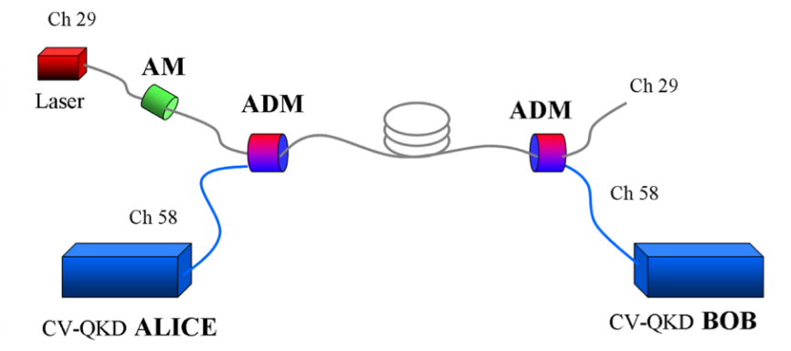
NOTE – ADM is the add/drop module and AM is the amplitude modulator which is used to control the "on and off" of the classical light.
Figure 12 – DWDM experimental schematic in [b-Kumar-1]
[b-Kumar-1] chose two transmission distances in this experiment: 25 km and 50 km. The results show that, under the condition of collective attack and reconciliation efficiency of 95%, the cases of 25 km and 50 km transmission distances can both support classical optical transmission power of 10 mW (highest) and 2 mW, respectively, as shown in Figure 13.
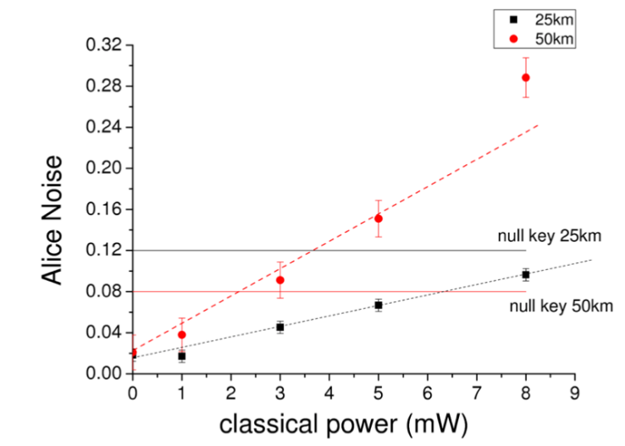
Figure 13 – Relationship between classical optical power excess noise introduced
into CV-QKD system [b-Kumar-1]
In 2015, [b-Kumar-2] conducted further research on CEQC based on previous experiments including the classical optical forward and reverse CEQC scenarios at different transmission distances. [b-Kumar-2] mainly studied the amount of excess noise introduced by spontaneous anti-stockes raman scattering (SASRS) and its effect on the performance of QKD systems in different scenarios.
NOTE – In the research of CEQC of classical and multiplexed quantum light, the noise introduced by Raman scattering is considered as the most important source of excess noise affecting CV-QKD systems.
In 2018, [b-Karinou] studied the feasibility of integrating CV-QKD into existing optical communications and WDM networks. The research mainly consisted of two parts: [b-Karinou] first studied the impact of spontaneous Raman scattering (SRS) noise on CV-QKD systems in different transmission scenarios (different transmission distances and different powers of classical signals in WDM). That is, at a certain transmission distance (such as 20km, 40km, 60km, and 80km), the excess noise introduced by Raman scattering increases with the increase of classical optical power, as shown in Figure 14.
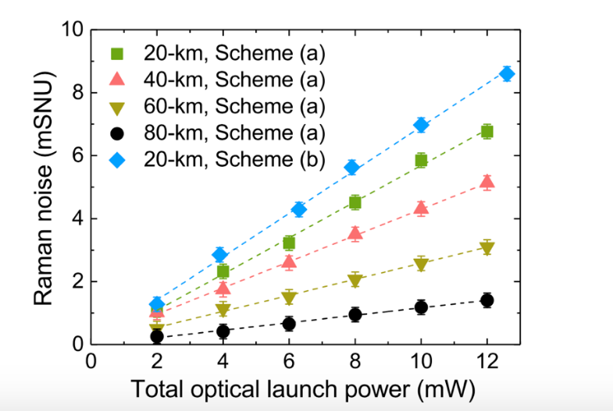
Figure 14 – Relationship between optical launch power and Raman noise
In addition, at certain optical launch power, the excess noise introduced by Raman scattering increases first and then decreases with the transmission distance, as shown in Figure 15.
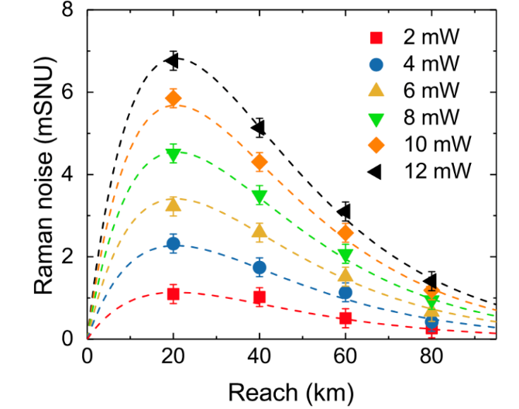
Figure 15 – Relationship between transmission distance and Raman noise
[b-Karinou] then demonstrated (for the first time) the use of the CV-QKD system to encrypt a 10GE client service over deployable optical transport network legacy equipment over 20 km as shown in Figure 16. The results showed the feasibility of the integration of the proposed scheme with legacy telecom equipment in existing WDM optical networks.
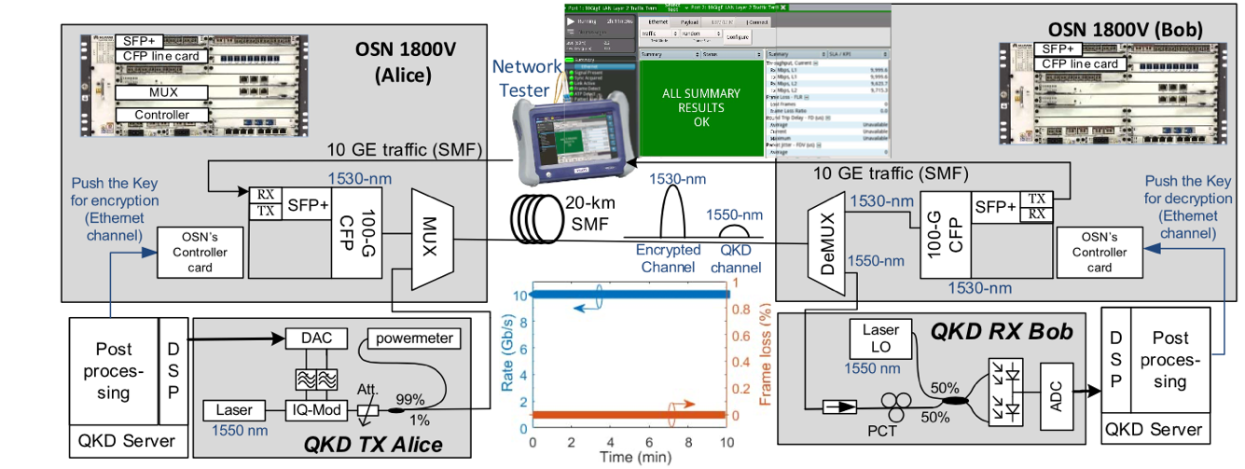
Figure 16 – Application of CV-QKD to OTN networks for real-time encryption
experiments on 10GE services [b-Karinou]
In 2018, [b-Eriksson-1] studied the impact of amplified spontaneous emission (ASE) noise on the performance of CV-QKD systems and proved that quantum signals could be co-transmitted with 18 classical signals by WDM in a 10 km fibre and that the CV-QKD system could run stably for more than 48 hours. The experiment was mainly composed of two parts, namely the ASE noise tolerance experiment and the classical optical CEQC experiment. The experimental schematic diagram is shown in Figure 17.
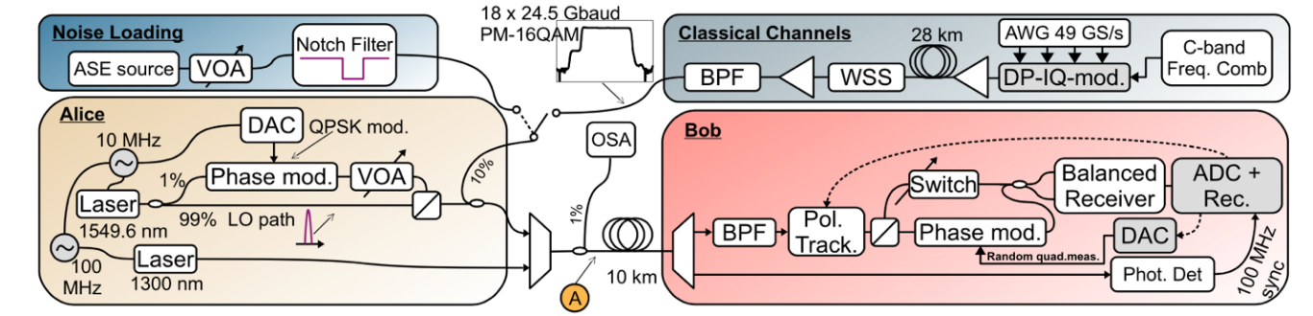
Figure 17 – Experimental scheme in [b-Eriksson-1]
In 2019, [b-Eriksson-2] studied the effect of inter-core crosstalk on classical channels in multicore fibres on CV-QKD. In this experiment, [b-Eriksson-2] selected a section of 19-core optical fibre with length of 10.1km: three cores to transmit classical business light and the other cores to transmit CV-QKD quantum signal light. The quantum channel was surrounded by 3 classical channels, as shown in Figure 18.
The transmitter generated 30 WDM channels of 24.5 Gbaud PM-16QAM with 100 GHz channel spacing and the multicore fibre with the QKD core surrounded by 3 cores loaded with the classical WDM channels. 30 channels of classical light are distributed to 3 fibre cores and each core transmits 10 channels (in this experiment, CV-QKD ran the Gaussian-modulated coherent-state protocol). The experimental results show that crosstalk from the classical channels prohibits secret key generation at the same wavelength. However, by assigning CV-QKD channels to wavelengths in the guard-bands between the classical channels, spatial multiplexing of CV-QKD and classical channels is possible.
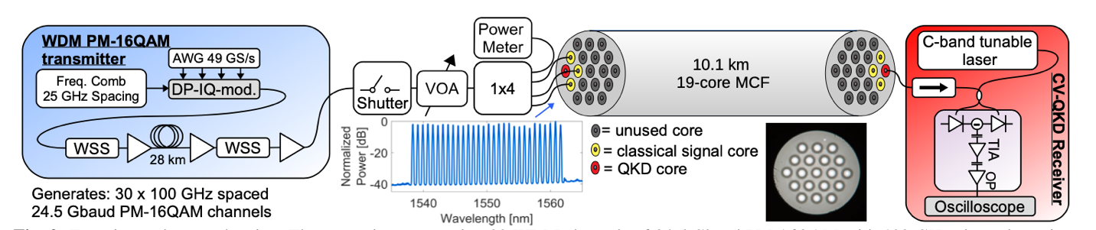
Figure 18 – Experimental schematic of the effect of crosstalk between cores
in a multicore fibre on the CV-QKD system
In 2019, [b-Kleis] studied the CEQC feasibility based on the CV-QKD system on the S-band (L-band) and the C-band DWDM system. The results show that, in comparison to previously proposed configurations, the number of co-propagating channels could be doubled. At a fibre length of 25 km, 56 DWDM channels with a total launch power of 14.5 dBm are tolerated by the quantum channel.
In 2017, test results were released of CEQC system based on commercial 8 tbps (80 × 100 Gbps) high-capacity DWDM system along ultra-long-distance transmission, realizing single span transmission of more than 100 km [b-Tang]. Under the condition that 80x100Gbps wavelengths are guaranteed to work normally, the QKD code rate of 80 km transmission distance is 8.1 kbps and the QKD code rate of 115 km transmission distance is 0.41 kbps [b-Tang].
In 2017, a CEQC experiment along 66 km fibre of existing network was realised for the first time and the impact of co-directional and contrary-directional transmission on the code rate of quantum key was verified [b-Mao]. By using a 20 GHz bandwidth filter, the quantum key code rate of CEQC system can reach 3.0 kb/s (G.652 fibre in the same direction), 4.5 kb/s (G.654 fibre in the same direction) and 5.1 kb/s (G.654 fibre in the contrary direction) respectively while the classical optical signal is 21 dBm [b-Mao].

7.2 CEQC scenarios
In the deployment of QKDN, there may be problems such as shortage of optical fibre resources, however, CEQC technology mainly solves this problem, thus it could be a suitable solution for QKDN construction. Additionally, CEQC technology could also be used to solve the problem of QKD network coverage to users and provide a fast coverage solution based on the existing optical fibre communication access network.
The connection between QKD devices needs to solve transmission problems of the quantum, synchronous and negotiated optical signals. These signals are combined and transmitted by the CEQC technology and as shown in Figure 19. The optical fibre applied can be effectively reduced and the QKD interface towards the fibre network simplified; this advantage could also improve the deployment speed.
Figure 19 – CEQC of QKD's multi-signals
In CEQC systems, the reconciliation channel can use a separated carrier, see Figure 20: (a), or be imported to the data channel from the classical optical devices, see Figure 20: (b).
(a) Reconciliation channel with independent carrier
(b) Reconciliation channel carried by data channel
Figure 20 – Combination of QKD network and existing optical fibre system

7.2.1 CEQC scenario A
The reconciliation information required for QKD occupies the OSC channel while the quantum and synchronous optical signals share the fibre with the combined signal of OTN system through the combiner. The quantum key provided by the QKD device can be used to encrypt the OPUK payload and the ciphertext could be packaged and transmitted through the OTN system. The OTN integrated with QKD enhances the ability to provide quantum leased line service. See Figure 21 for an illustration of the combination of QKD and OTN systems.
Figure 21 – CEQC between QKD and OTN system

7.2.2 CEQC scenario B
For leased line users that choose a quantum service, they would need to use a quantum key to encrypt their data. Although the QKDN and leased line network could either be integrated or left as independent networks, the user access to the operator's computer room would basically be the same path. The CEQC mode, as shown in Figure 22, enables operators to provide users with "one fibre overall" solution, reducing the fibre consumption and door-to-door construction times.
Figure 22 – CEQC access scheme to operator network

7.2.3 CEQC scenario C
For QKD users covered by FTTx, the PON network can be considered to solve QKD signals' bearing problem, as shown in Figure 23. The reconciliation channel can be imported to the user data channel while the quantum and synchronous optical signals choose different wavelengths from the up-link and down-link optical signals of PON. Due to the limitation of the ODN coupling ratio, it is necessary to solve the problems of classical optical signal interference and large fibre attenuation in practical application.
Figure 23 – CEQC Scheme for PON access users

7.3 Impact of classical light for QKD
The impact of classical light for QKD in typical band assignment schemes is analysed in this subclause.

7.3.1 Noise source
When classical light and quantum signals are co-propagating, noise sources are from leaked light, in-band ASE noise, Raman scattering and four-wave mixing. Among them, Raman scattering has the largest effect. Various noise sources in the CEQC scenario are analysed as follows:
a) Leaked light: The limited isolation of CEQC devices will lead to the leakage of classical light into the band of the quantum signal. Such type of noise belongs to out-band noise and the solution to prohibit such noise is to improve the channel isolation of the CEQC device, and then reducing out-band noise.
b) In-band ASE noise: In classical optical communication, EDFA has been widely used, however, any practical devices are non-ideal. For practical EDFA, it is not an ideal single-frequency amplification. The spontaneous emission process will generate other frequency components, and often has a wide frequency band (tens of nm), which will extend to the wavelength of quantum light, thus contributes to in-band amplified spontaneous emission (ASE) noise.
c) Four-wave-mixing: Four-wave-mixing (FWM) is a kind of non-linear optical fibre effect caused by the disturbance of the refractive index of the optical fibre during the transmission process of the pump light (classical light) which will generate a variety of noise signals at new frequencies. Such noise may affect the performance of the QKD system as the noise is the same frequency as the quantum signal. Simply considering the case of three classical lights and assuming the three different light frequencies are$f_{i}、, f_{j}, f_{k} (i≠ j≠k)$ respectively, six new frequencies would be generated after four-wave mixing in the following form:
$$f_{ijk} = f_{i} + f_{j}-f_{k}$$
When the frequency of the generated noise is exactly the same as the frequency of the quantum signal, the noise will become in-band noise and cannot be filtered. Thus, such out-band noise will decrease the secure transmission distance and secure secret key rate.
d) Raman scattering noise: When classical light is transmitted in an optical fibre, the interaction of optical signals with the optical fibre will cause scattering noise, including Rayleigh scattering, Brillouin scattering and Raman scattering. Among them, the noise spectrum generated by Rayleigh scattering and Brillouin scattering only exists in the range of about 10 GHz near the pump light and the most common DWDM system currently has a spectral interval of 100 GHz and 200 GHz so the effect on the quantum signal can be ignored [b-Kleis]. Raman scattering noise has a wide spectrum (200nm around the noise source). For C-band quantum signals and classical optical signal wavelength division multiplexing systems, Raman scattering noise will cover the quantum channel wavelength range, which will cause quantum signals.

7.3.2 Evaluation of the impact of classical light on QKD system
The impact of the several noise sources introduced by classical light in clause ‎7.3.1 on DV-QKD and CV-QKD systems are described in this subclause. To simplify the analysis, a scenario where there is only one path of classical light passing by adjacent channel is first considered and the schematic of CEQC of the classical optical and quantum signal is shown in Figure 24.
Figure 24 – Typical schematic of CEQC of classical optical and QKD quantum signal
Appendix I.2 provides some experimental results which work out the impact on the performance of QKD from factors such as the channel isolation, channel bandwidth and classical optical power

7.4 CEQC schemes for DV-QKD systems
The CEQC scheme of quantum and classical channels includes WDM, TDM, space division multiplexing (SDM) and so on. Among them, TDM mode can avoid the influence of Raman scattering noise on the quantum light, but the implementation is too complex as it requires the inter-operation between QKD system and classical optical system in time. For SDM mode, it is necessary to deploy multimode multi-core fibre which is rarely used in practice. At present, WDM mode is the most mature and widely used.
According to the characteristics of optical modules used in the classic optical communication system, WDM can be divided into wide spectrum WDM based on grey optical communication and WDM based on colour optical communication. The transmission wavelength of grey light module generally fluctuates in a wide range, while that of colour light module generally meets the requirements of ITU-T G.694.1 (DWDM) or G.694.2 (CWDM). Grey light communication is mainly used in short and medium distance transmission, and colour optical communication is generally used in long and medium distance or multi wave systems.

7.4.1 CEQC scheme based on MSTP system
The existing classic optical communication system (non-WDM system) mainly adopts grey light interconnection. Dual-fibre bidi optical module mainly adopts 1310 nm and 1550 nm, while single fibre bidi optical module mainly adopts 1310 nm/1550 nm and 1270 nm/1330 nm. Therefore, if a quantum optical signal, synchronous optical signal and classical signal (data signal and reconciliation signal) adopt different wavelengths and pass through WDM/demultiplexer, they can realise the CEQC of quantum and classical channels.
This mode is suitable for the multi-channel interconnection of QKD devices, the combination of QKDN and existing optical fibre system and the access of leased line users of quantum secure communication. The classic optical fibre networks supported include MSTP, PTN, IP-MAN and other grey optical interconnection networks.
To verify the feasibility of CEQC scheme based on grey light communication, China Telecom has set up a networking environment in the laboratory based on the interconnection of MSTP equipment and QKD device. The QKD devices used here include polarization coding and time-phase coding devices. The experimental system is shown in Figure 25, in which the reconciliation channel of the QKD device and the data channel of the MSTP device are regarded as classic channels and the quantum channel of the QKD realises the CEQC through the wavelength division multiplexing device.
Figure 25 – Experimental system of CEQC based on grey light communication
In the experiment, MSTP equipment is interconnected by grey light module, which includes 2.5G, 155 m, GE (10 km, 40 km, 80 km) light module. The specific information of the light module is shown in Table 5.
Table 5 – Parameters of classic optical modules
Module | Distance (km) | Mode | Wavelength (nm) | Power (dBm) | Power Measured (dBm) | Receiving sensitivity (dBm)
2.5G-1310nm-40km-SM-ESFP | 40 | Single longitudinal | 1280～1335 | –2～3 | 0.99 | –27～–9
1.25G-1310nm-10km-SM-ESFP | 10 | Multiple longitudinal | 1270～1355 | –9～–3 | –4.91 | –20～–3
155M-1310nm-40km-SM-ESFP | 40 | Multiple longitudinal | 1263～1360 | –5～0 | –2.44 | –34～–10
1.25G-1310nm-40km-SM-ESFP | 40 | Single longitudinal | 1275～1350 | –5～0 | –0.57 | –23～–3
1.25G-SFP-CWDM-1310nm-80KM-DDM | 80 | Single longitudinal | 1304.5～1317.5 | 0～3 | 2.42 | –32～–3
As the grey light module used in MSTP interconnection has certain generality, the conclusion derived from the test results can also be extended to the grey light communication system.
The CEQC equipment mainly uses WDM technology through wavelength isolation and narrowband filtering to realise the transmission of classical optical signal and quantum optical signal multiplexing together in the same fibre. The parameters of the CEQC equipment used in the experiment are shown in Table 6.
Table 6 – Parameters of CEQC equipment
Parameters | Units | Values
Equipment type |  | Multiplexing | Demultiplexing
Classical light wavelength | nm | 1310±10
Quantum light wavelength | nm | 1550.12±0.1
Sync-light wavelength | nm | 1569.59±0.1
Classical channel insertion loss | dB | ≤1.5 @1310 nm | ≤1.0 @1310 nm
Quantum channel insertion loss | dB | ≤0.8 @1550 nm | ≤1.4 @1550 nm
Sync-channel insertion loss | dB | ≤1.0 @1570 nm | ≤1.4 @1570 nm
Classical channel adjustable attenuation range | dB | 0~60
Quantum channel isolation | dB | >150@1310 nm
The parameters of the polarization coding QKD device used in the experiment are shown in Table 7.
Table 7 – Parameters of 40M polarization coding QKD
Parameters | Units | Values
Working frequency | MHz | 40±0.02
Quantum light wavelength | nm | 1550.12±0.1
Sync-light wavelength | nm | 1569.59±0.1
Typical code rate@25℃ | bps | 15 k@10 dB
Long distance code rate@25℃ | bps | 1 k@17 dB
The parameters of time-phase coding QKD device are shown in Table 8.
Table 8 – Parameters of time-phase coding QKD
Parameters | Units | Values
Working frequency | MHz | 312.5±0.01
Quantum light wavelength | nm | 1550.12±0.1
Sync-light wavelength | nm | 1569.59±0.1
Typical code rate@25℃ | bps | 50 k@10 dB
Long distance code rate@25℃ | bps | 1 k@22 dB
The detection efficiency of QKD involved in the experiment is 10% ~ 15%.

7.4.2 CEQC scheme based on WDM system
In the CEQC scheme, the scheme of colour optical communication system can support more classical channels and quantum channels. Colour optical communication system includes DWDM system and CWDM system.
This mode is applicable to application fields such as multi-channel interconnection of QKD devices, stack interconnection of QKD devices, combination of QKDN and existing optical fibre communication system, access of quantum secure communication leased line users, etc.
To verify the feasibility of the CEQC scheme based on colour optical communication system, China Telecom has set up a networking environment based on the CEQC interconnection among OTN equipment and QKD devices. The topology is shown in Figure 26.
Figure 26 – CEQC test system based on WDM system
The OTN equipment of manufacturer A supports 8-wave transmission and the full load classical service data bandwidth is 400 Gbit/s. The QKD device is a 40M and a GHz polarization coding QKD device. The central wavelength of the quantum optical signal is 1310nm, the central wavelength of the synchronous optical signal is 1490nm and the optical wavelength of the classic channel after combining is 1530 nm ~ 1560 nm. The reconciliation channel is carried by the OSC channel of the OTN system.
OTN equipment of manufacturer B supports up to 80-wave transmission with single wave 100 Gbit/s. The QKD device is a GHz polarization coding QKD device and the central wavelength of the quantum optical signal is 1310 nm while the central wavelength of the synchronous optical signal is 1490 nm.
The parameters of the CEQC equipment used in the experiment are shown in Table 9.
Table 9 – Parameters of CEQC equipment
Parameters | Units | Values
Equipment type |  | Multiplexing | Demultiplexing
Classical light wavelength | nm | 1520~1570
Quantum light wavelength | nm | 1310±0.1
Sync-light wavelength | nm | 1490±0.1
Classical channel insertion loss | dB | ≤1.5 @1550 nm | ≤1.5 @1550 nm
Quantum channel insertion loss | dB | ≤0.7 @1310 nm | ≤0.7 @1310 nm
Sync-channel insertion loss | dB | ≤1.0 @1490 nm | ≤1.0 @1490 nm
Classical channel adjustable attenuation range | dB | 0~60
Quantum channel isolation | dB | >150@1310 nm
The parameters of the GHz polarization coding QKD device used in the experiment are shown in Table 10.
Table 10 – Parameters of the GHz polarization coding QKD
Parameters | Units | Values
Working frequency | MHz | 1250±0.02
Quantum light wavelength | nm | 1310±0.1
Sync-light wavelength | nm | 1490±0.1
Typical code rate@25℃ | bps | 120 k@10 dB
Long distance code rate@25℃ | bps | 1 k@26 dB

7.5 CEQC schemes for CV-QKD systems with G.698.4 system
There has been rapid development in CV-QKD in recent years; the CV-QKD system can resist noise effectively thanks to its coherent detection [b-Karinou] and can be integrated into classical communication networks [b-Kumar], especially into the DWDM system.
The [ITU-T G.698.4] system is a multichannel bidirectional DWDM system as shown in Figure 27. This system can be used in 5G front-haul network and metro access network. Low-cost C-band tunable laser and bidirectional OD/OM/OADM is used. For metro or access application, the maximum reach is about 20km and no optical amplifier is used.
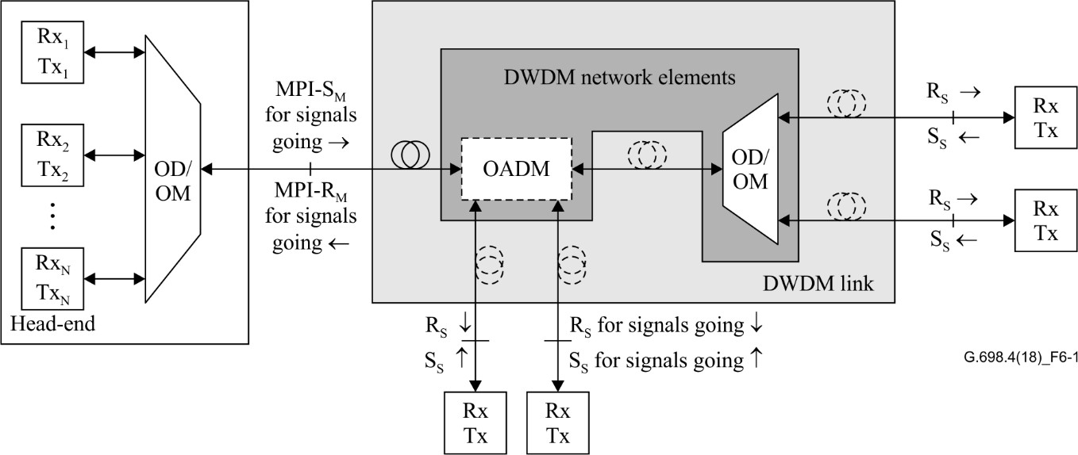
Figure 27 – G.698.4 system model
The G.698.4 system does not contain an optical amplifier, which is not allowed in the QKD system. Thus, it is very convenient to integrate CV-QKD with a G.698.4 system. In addition, CV-QKD can use the C-band laser which is utilized in the G.698.4 system, therefore, unlike other DV-QKD CEQC schemes, no extra multiplexer/de-multiplexer for the O-band signal is needed. The network scheme based on CV-QKD and G.698.4 system for access network application is shown in Figure 28.
Figure 28 – Network scheme based on CV-QKD and G.698.4 system
The network is very flexible because the service data can be add/drop at any site and the wavelength of DWDM can also be assigned flexibly. For example, site A is usually a central office (CO) where user data is aggregated. The wavelength to each site along the fibre can be assigned at site A. The wavelength of the optical modules at other sites can be adjusted automatically in the G.698.4 system. The CV-QKD equipment utilizes λ₁ to generate the quantum key while the encrypted service data can be transmitted with λ₂. Other service data without encryption can be carried by λ₃ or any other wavelength and dropped at site B or any other site.
In the future, CV-QKD equipment could also be integrated as one card into the G.698.4 system and can share the same tuneable optical module. See Appendix I.3 for some experimental results of CEQC systems of CV-QKD with G.698.4.

8 Conclusions
Although QKDN transport technologies have been in development for decades, its joint research and standardization need to be strengthened further. Based on the analysis in this report and the experimental results in Appendix I.2 and Appendix I.3, the following observations can be drawn:
1) CEQC technology can save fibre resource consumption and reduce network construction cost. It is an important research direction in the field of quantum secure communication.
2) Up to now, the CEQC schemes are mainly based on WDM technology, and their feasibility is verified by laboratory experiments and field trials.
3) The high power of the classical optical affects QKD to a certain extent. In case that ensuring the normal operation and maintenance margin of the classical optical communication system, the CEQC based on WDM technology can be realised by adjusting the optical transmission power of the classical optical communication system.
4) According to the experiment results, it is suggested that the mode that quantum signal propagate in the same direction with the classic signal should be preferred.
5) According to the experiment results, the proposed CEQC schemes for both DV-QKD and CV-QKD systems can facilitate the deployment of QKD and classical networks together and enable the QKD-based applications cost-effectively.
The following are some standardization considerations for QKD transport technologies, which are suggested to be promoted with the support of ITU-T SG15:
1) The QKD transport system architecture, reference points, technical requirements for key components (e.g., single photon detector) should be standardized to ensure interoperability and compatibility with the existing optical communication networks.
2) The technical requirements for implementing CEQC solutions should be standardized, e.g., central wavelength distribution for various signals and their wavelength intervals, the isolation requirements between quantum signal and classic signal, reasonable optical transmission power limitation.
3) The test methods of QKD transport systems should also be studied and standardized to ensure technical conformance.

Appendix I
Experimental results

I.1 Experimental results about the impact of classical light on QKD system

I.1.1 Channel isolation requirements for CV-QKD and DV-QKD
According to the results in Figure I.1, under CEQC scenario, the DV-QKD system requires higher channel isolation than the CV-QKD system. However, in practice, the channel isolation of DWDM system is commonly about 30 dB and it is difficult to increase it to a relatively high value (such as 70 dB). That is, if the channel isolation cannot be sufficiently high, it is necessary to reduce the influence of crosstalk by reducing the classical optical power or reducing the filter bandwidth. However, this will also be limited by the practical system. Increasing the distance between the band of classic and quantum signals to increase the isolation could also be considered.
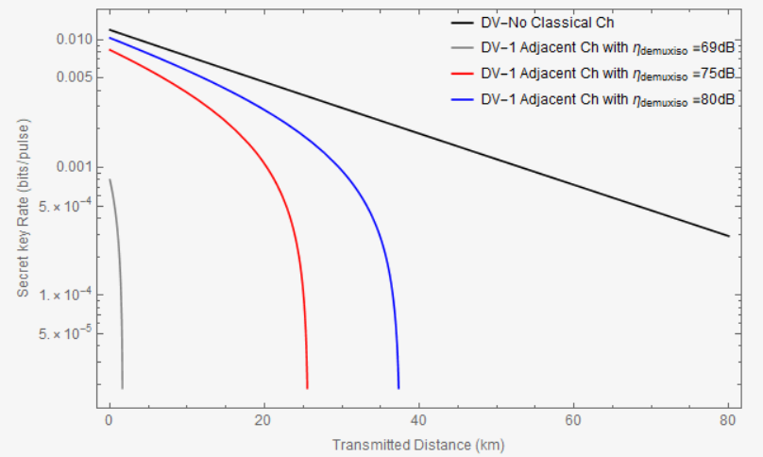
Figure I.1 – Impact of channel isolation on secure secret key rate of DV-QKD System
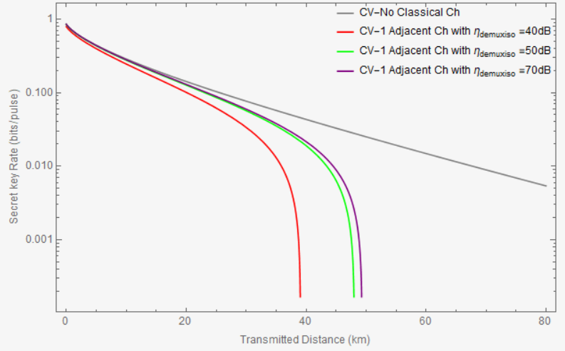
Figure I.2 – Impact of channel isolation on secure secret key rate of CV-QKD System

I.1.2 Channel bandwidth requirements for CV-QKD and DV-QKD system
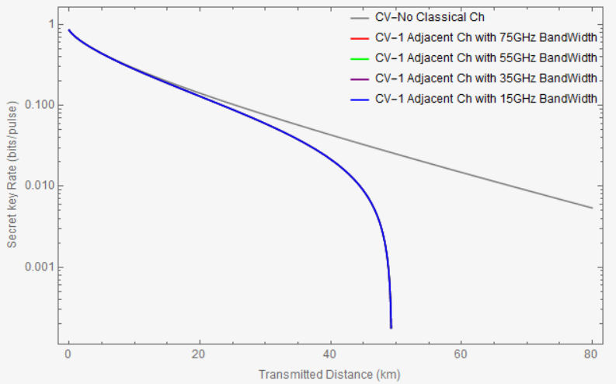
Figure I.3 – Impact of quantum channel bandwidth on secure secret
key rate of CV-QKD system
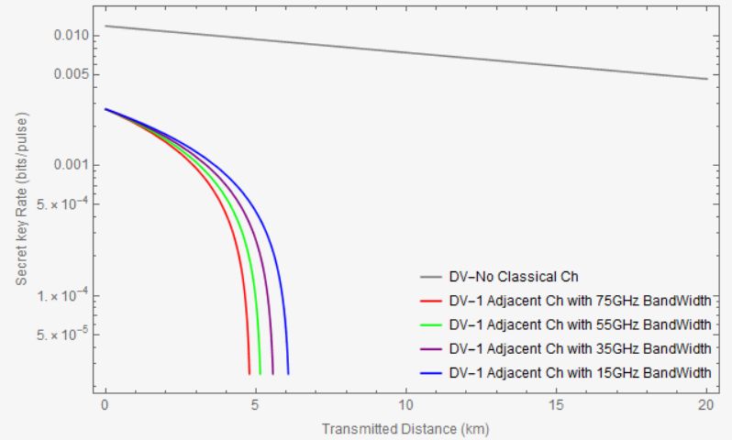
Figure I.4 – Impact of quantum channel bandwidth on secure secret
key rate of DV-QKD system

I.1.3 Impact of classical optical power (receiver) on the performance of CV-QKD and DV-QKD systems
The results in Figures I.5 and I.6 show that the QKD system will be affected by classical light and the stronger the classical optical power is, the greater the impact is.
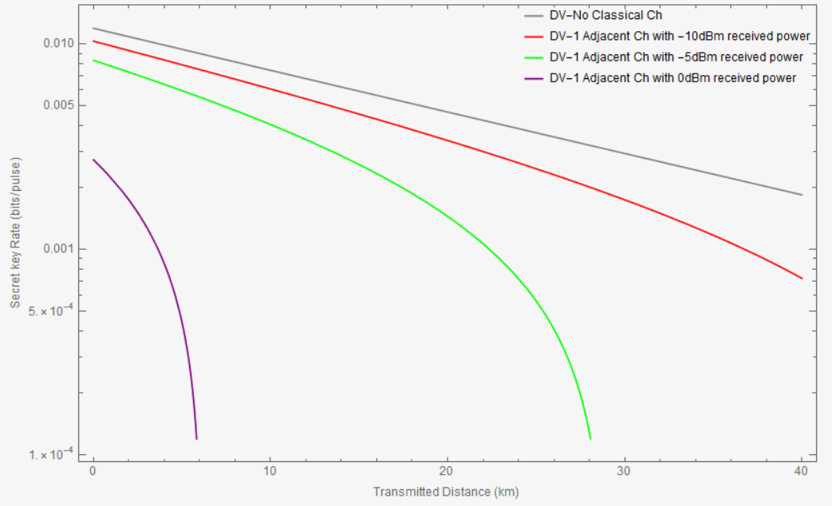
Figure I.5 – Secure secret key rate of DV-QKD system under different classical optical power
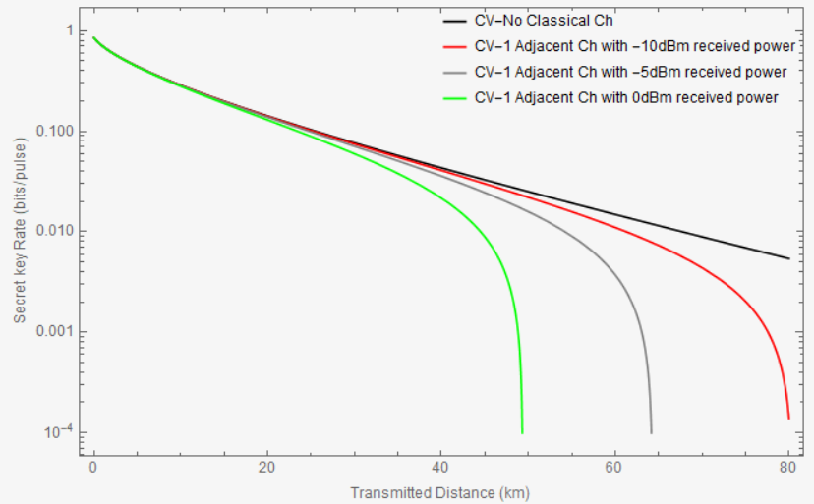
Figure I.6 – Secure secret key rate of CV-QKD system under different classical optical power

I.2 Experimental results of the CEQC Systems of DV-QKD

I.2.1 QKD key rate based on CEQC with MSTP system with the same direction
When the classical optical signal, the quantum optical signal and the synchronous optical signal propagate in the same direction, the classical light passes through the blue link in Figure I.7.

Figure I.7 – QKD key rates figure based on MSTP system and 40M Polarization
coding QKD with the same direction
The QKD key rates tested with 40M polarization coding QKD in cases without classic light and different optical modules at different transmission distances are shown in Figure I.7 and Table I.1. To ensure the QKD can stably generate the quantum key, the power of the classical optical signal needs to be decreased. When the maximum optical power in the classical optical (which refers to the maximum optical power that the QKD can stably work) is adjusted, the classical optical communication system works well (no packet loss and system alarm).
Table I.1 – QKD key rates based on MSTP system and 40M polarization
coding QKD with the same direction
Classic optical module | Classic signal power input fibre (dBm） | Fibre distance(km) | Averaged QKD key rate (kbps)
W/O classic light | – | 0 | 53.828
 | – | 10 | 35.584
 | – | 20 | 39.245
 | – | 30 | 30.898
 | – | 40 | 29.404
 | – | 50 | 13.711
 | – | 60 | 13.689
2.5G | 1.60 | 0 | 43.058
 | –1.34 | 10 | 36.996
 | –1.84 | 20 | 28.498
 | 0.14 | 30 | 11.929
 | 0.14 | 40 | 18.862
 | 0.06 | 50 | 6.241
 | 0.06 | 60 | 3.867
155M | –2.44 | 0 | 52.605
 | –3.97 | 10 | 35.165
 | –3.97 | 20 | 34.156
 | –3.97 | 30 | 10.029
 | –2.44 | 40 | 13.686
 | –2.48 | 50 | 10.614
 | –2.44 | 60 | 3.236
GE | –4.91 | 0 | 52.951
 | –4.91 | 10 | 33.387
 | –4.91 | 20 | 31.780
 | –4.91 | 30 | 30.367
 | –4.91 | 40 | 15.645
 | –4.91 | 50 | 8.285
 | –4.91 | 60 | 5.805
In the case of introducing the noise caused by different classical optical signals, all the quantum key distribution devices in the same direction CEQC system can stably code but the coding rate will decrease due to the influence of noise such as co Raman scattering. With the increase of fibre distance in the common fibre system, the rate of quantum key coding decreases which is caused by the attenuation of quantum optical signal.

I.2.2 CEQC key rate based on MSTP system with the contrary direction
When the quantum optical signal and the synchronous optical signal propagate in the contrary direction from the classical optical signal, the classical light passes through the red link in Figure I.8.

Figure I.8 – QKD key rates figure based on MSTP system and 40M polarization
coding QKD with the contrary direction
The QKD key rates tested with 40M polarization coding QKD in cases without classic light and different optical modules at different transmission distances are shown in Figure I.8 and Table I.2.
Table I.2 – QKD key rates based on MSTP system and 40M Polarization
coding QKD with the contrary direction
Classic optical module | Classic signal power input fibre（dBm） | Fibre distance(km) | Averaged QKD key rate (kbps)
2.5G | 1.5 | 0 | 36.367
 | –2.93 | 10 | 31.591
 | –2.93 | 20 | 24.107
 | –3.49 | 30 | 20.047
 | –4.53 | 40 | 22.756
 | –5.5 | 50 | 14.116
 | –5.5 | 60 | 5.387
155M | –2.44 | 0 | 54.374
 | –3.91 | 10 | 45.137
 | –4.30 | 20 | 33.298
 | –5.23 | 30 | 26.280
 | –5.23 | 40 | 16.845
 | –6.73 | 50 | 10.000
 | –9.23 | 60 | 7.680
GE | –4.91 | 0 | 49.493
 | –4.91 | 10 | 45.129
 | –6.03 | 20 | 39.618
 | –6.03 | 30 | 18.556
 | –7.00 | 40 | 15.831
 | –8.85 | 50 | 10.169
 | –10.03 | 60 | 6.356
According to the test results based on MSTP system, it can be seen that the noise introduced by the classical gray light signal in the CEQC system has an impact on QKD key rate. However, under the condition of controlling the attenuation of the classical optical power, the quantum key distribution devices with different modulation modes can still stably code to meet the system requirements. With the increase of fibre distance, the QKD key rate decreases. In addition, when the quantum signals propagate in the contrary direction from the classic signal, it requires lower transmission power of the classic light, which affects the transmission distance of the classical optical communication system.

I.2.3 CEQC QKD key rate based on WDM system
Applying OTN as the classic optical system, the OTN transfers 80 waves, with each single wave 100 Gbit/s data rate. The QKD key rates tested with GHz polarization coding QKD in cases without and with classic light at different transmission distances are shown in Table I.3 and Figure I.9 where both cases that quantum signals propagate in the same and the contrary direction from the classic signal are involved.
Table I.3 – QKD key rates based on WDM system and GHz polarization coding QKD
Classic light | Classic signal power input fibre（dBm） | Fibre distance (km) | Averaged QKD key rate (kbps)
w/o classic light | / | 0 | 30.8
 |  | 20 | 12.5
 |  | 40 | 3.8
 |  | 50 | 2.5
Same direction | 19.5 | 0 | 32.9
 | 14.6 | 20 | 11.5
 | 18.1 | 40 | 1.6
 | 18.5 | 50 | 2.5
Contrary direction | 19.5 | 0 | 35
 | 14.3 | 20 | 12.2
 | 14.0 | 40 | 3.4
 | 13.4 | 50 | 3.1

Figure I.9 – QKD key rates figure based on WDM system and GHz polarization coding QKD
When the quantum signal propagates in the same direction with the classic light, the maximum transmission power of classical light first decreases and then increases with the increase of transmission distance. When the quantum signal propagates in the contrary direction from the classical light, the maximum classical light transmission power decreases with the increase of transmission distance until it cannot operate stably.

I.3 Experimental results of the CEQC schemes of CV-QKD with G.698.4
To verify the feasibility of integrating CV-QKD with G.698.4 system, an experiment to study the influence between CV-QKD and classical optical communication is made. The experiment setup is shown in Figure I.10.
Figure I.10 – Experiment setup
The wavelength of CV-QKD is fixed at 1550.12 nm (ITU 34# channel). Service data 1 needs high level security protection, encrypted in a VPN equipment using the secure secret key generated by CV-QKD system. The encrypted data is carried by channel 59/33 because G.6998.4 is a bidirectional system. Service data 2 and 3 without encryption are carried by channel 57/31, channel 55/29, respectively. The wavelengths from G.698.4 equipment vary to study the influence from different scenarios.
First, only one classical channel is co-propagated and the influence from different channel spaces is tested. Restricted by the 6-channel MUX/DEMUX, only the one classical channel varying from channel 59/33, channel 57/31, channel 55/29 is tested. As shown in Figure. I.11, the secure secret key rate has not been influenced dramatically in comparison to the one without CEQC when the link loss is 11.9 dB and 15.6 dB, respectively.
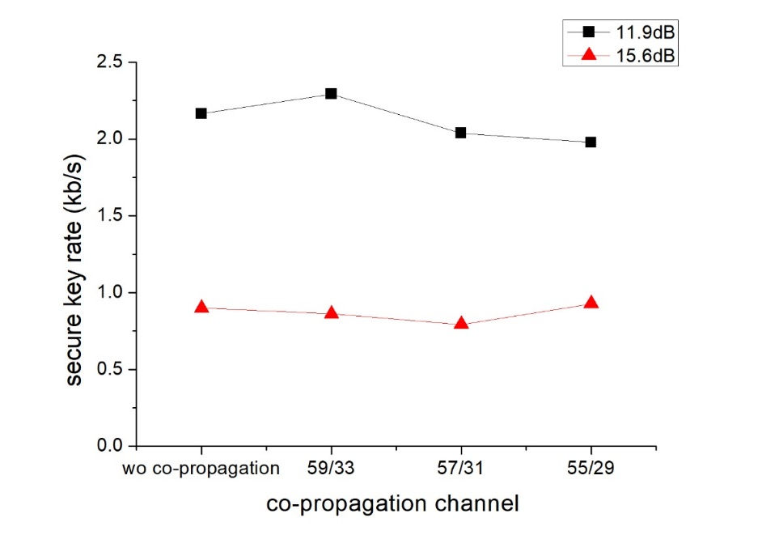
Figure I.11 – Secure secret key rate over different channel space
between CV-QKD and classical signal
Next the influence from different classical channel amounts is tested. As shown in Figure I.12, as the CEQC classical channel increases from 1 to 3, the secure secret key rate remains stable when the link loss is 11.9 dB and 15.6 dB, respectively.
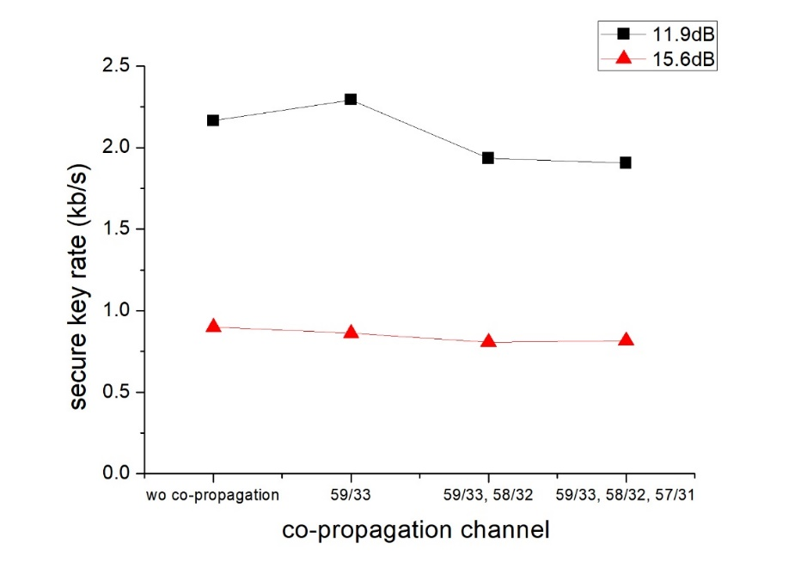
Figure I.12 – Secure key rate over different channel amount of classical signal
The impact of CV-QKD on classical system is also tested and, during the experiment, data 1, 2, 3 were observed and no package loss was found.

Bibliography

[b-Bennett] Bennett, C. H. and Brassard, G. (1984) Quantum cryptography: Public-key distribution and coin tossing. In Proceedings of IEEE International Conference on Computers, Systems and Signal Processing, Bangalore, India, pp. 175–179.
[b-Boaron] Boaron, A., Boso, G., Rusca, D., Vulliez, C., Autebert, C., Caloz, M., Perrenoud, M., Gras, G., Bussières, F., Li, M.-J., Nolan, D., Martin, A. and Zbinden, H. (2018), Secure Quantum Key Distribution over 421 km of Optical Fiber. Physical Review Letters Vol. 121, No. 19.
[b-Brown] Brown, R. G. W., Jones, R., Rarity, J. G. and Ridley, K. D. (1987), Characterization of silicon avalanche photodiodes for photon correlation measurements. 2: Active quenching. Applied Optics Vol. 26, No. 12, pp. 2383-2389.
[b-Bradley] Bradley, T. D., et al. (2019), Antiresonant hollow core fibre with 0.65 dB/km attenuation across the C and L telecommunication bands, 45th European Conference on Optical Communication (ECOC 2019), pp. 1-4.
[b-Chen-1] Chen, T.-Y., Wang, J., Liang, H., Liu, W.-Y., Liu, Y., Jiang, X., Wang, Y., Wan, X., Cai, W.-Q., Ju, L., Chen, L.-K., Wang, L.-J., Gao, Y., Chen, K., Peng, C.-Z., Chen, Z.-B. and Pan, J.-W. (2010), Metropolitan all-pass and inter-city quantum communication network. Optics Express Vol. 18, No. 26, pp. 27217- 27225
[b-Chen-2] Chen, J.-P., Zhang, C., Liu, Y., Jiang, C., Zhang, W., Hu, X.-L., Guan, J.-Y., Yu, Z.-W., Xu, H., Lin, J., Li, M.-J., Chen, H., Li, H., You, L., Wang, Z., Wang, X.-B., Zhang, Q. and Pan, J.-W. (2020), Sending-or-Not-Sending with Independent Lasers: Secure Twin-Field Quantum Key Distribution over 509 km. Physical Review Letters Vol. 124, No. 7.
[b-Dixon] Dixon, A. R., Yuan, Z. L., Dynes, J. F., Sharpe, A. W. and Shields, A. J. (2008), Gigahertz decoy quantum key distribution with 1 Mbit/s secure key rate. Optics Express Vol. 16, No. 23, pp. 18790-18797.
[b-Eriksson-1] Eriksson, T., Hirano, T., Rademacher, G., Puttnam, B., Luís, R., Fujiwara, M., Namiki, R., Awaji, Y., Takeoka, M., Wada, N. and Sasaki M. (2019), Joint Propagation of Continuous Variable Quantum Key Distribution and $18\times 24.5$ Gbaud PM-16QAM Channels. In 2018 European Conference on Optical Communication (ECOC).
[b-Eriksson-2] Eriksson, T. A., Puttnam, B. J., Rademacher, G., Luís, R. S., Takeoka, M., Awaji, Y., Sasaki, M. and Wada, N. (2019), Inter-core crosstalk impact of classical channels on CV-QKD in multicore fiber transmission. In 2019 Optical Fiber Communications Conference and Exhibition (OFC), San Diego, United States.
[b-Fröhlich-1] Fröhlich, B., Dynes, J. F., Lucamarini, M., Sharpe, A. S., Tam, S. W.-B., Yuan, Z. and Shields, A. J. (2015), Quantum secured gigabit optical access networks. Scientific Reports Vol. 5, No. 18121.
[b-Fröhlich-2] Fröhlich, B., Dynes, J. F., Lucamarini, M., Sharpe, A. W., Yuan, Z. and Shields, A. J. (2013), A quantum access network. Nature Vol. 501, pp. 69–72.
[b-Gol'tsman] Gol'tsman, G. N., Okunev, O., Chulkova, G., Lipatov, A., Semenov, A., Smirnov, K., Voronov, B. and Dzardanov, A. (2001), Picosecond superconducting single-photon optical detector. Applied Physics Letters Vol. 79, No. 6, pp. 705–707.
[b-Hadfield] Hadfield, R. (2009), Single-photon detectors for optical quantum information applications. Naure Photonics Vol. 3, pp. 696-705.
[b-Haitz] Haitz, R.H. (1965), Mechanisms Contributing to the Noise Pulse Rate of Avalanche Diodes. Journal of Applied Physics Vol. 36, pp. 3123-3131.
[b-Karinou] Karinou, F., Brunner, H., Fung, C., Comandar, L., Bettelli, S., Hillerkuss, D., Kuschnerov, M., Mikroulis, S., Wang, D., Xie, C., Peev, M. and Poppe, A. (2018), Toward the Integration of CV Quantum Key Distribution in Deployed Optical Networks. IEEE Photonics Technology Letters Vol. 30, No. 7, pp. 650-653.
[b-Kleis] Kleis, S., Steinmayer, J., Derksen, R. H. and Schaeffer, C. G. (2019), Experimental Investigation of Heterodyne Quantum Key Distribution in the S-Band Embedded in a Commercial DWDM System. In Optical Fiber Communication Conference, San Diego, United States.
[b-Kumar-1] Kumar, R., Qin, H. and Alléaume, R. (2014), Experimental demonstration of the coexistence of continuous-variable quantum key distribution with an intense DWDM classical channel. In CLEO: QELS_Fundamental Science, San Jose, California. Optical Society of America.
[b-Kumar-2] Kumar, R., Qin, H. and Alléaume, R. (2015), Coexistence of continuous variable QKD with intense DWDM classical channels. New Journal of Physics Vol. 17, No. 4, p. 043027.
[b-Lee] Lee, B. (2021), Quantum transport technology. In ITU/IEC/ IEEE UK & Ireland Photonics Chapter Joint Symposium on Quantum Transport Technology, April. https://www.itu.int/en/ITU-T/webinars/20210428/Pages/default.aspx
[b-Liu] Liu, H., Wang, W., Wei, K., Fang, X.-T., Li, L., Liu, N.-L., Liang, H., Zhang, S.-J., Zhang, W., Li, H., You, L., Wang, Z., Lo, H.-K., Chen, T.-Y., Xu, F. and Pan, J.-W. (2019), Experimental Demonstration of High-Rate Measurement-Device-Independent Quantum Key Distribution over Asymmetric Channels. Physical Review Letters Vol. 122, No. 16.
[b-Lucamarini] Lucamarini, M., Patel, K. A., Dynes, J. F., Fröhlich, B., Sharpe, A. W., Dixon, A. R., Yuan, Z. L., Penty, R. V. and Shields, A. J. (2013), Efficient decoy-state quantum key distribution with quantified security. Optics Express Vol. 21, No. 21, pp. 24550- 24565.
[b-Mao] Mao, Y., Wang, B., Zhao, C., Wang, G., Wang, R., Wang, H., Zhou, F., Nie, J., Chen, Q., Zhao, Y., Zhang, Q., Zhang, J., Chen, T.-Y. and Pan, J.-W. (2018), Integrating quantum key distribution with classical communications in backbone fiber network. Optics Express, Vol. 26, No. 5.
[b-Morton] Morton, G. A. (1949), Photomultipliers for Scintillation Counting. RCA Review 10, pp. 525-553.
[b-Qi] Qi, B., Zhu, W., Qian, L. and Lo, H.-K., (2010), Feasibility of quantum key distribution through a dense wavelength division multiplexing network. New Journal of Physics Vol. 12, No. 10.
[b-QIT4N D2.1] ITU-T Technical Report (2021), Quantum information technology for networks terminology: Quantum Key Distribution Network.
[b-Rosenberg-1] Rosenberg, D., Harrington, J. W., Rice, P. R., Hiskett, P. A., Peterson, C. G., Hughes, R. J., Lita, A. E., Nam, S. W. and Nordholt, J. E. (2007), Long-Distance Decoy-State Quantum Key Distribution in Optical Fiber. Physical Review Letters Vol. 98, No. 1.
[b-Rosenberg-2] Rosenberg, D., Peterson, C. G., Harrington, J. W., Rice, P. R., Dallmann, N., Tyagi, K. T., McCabe, K. P., Nam, S., Baek, B., Hadfield, R. H., Hughes, R. J. and Nordholt, J. E. (2009), Practical long-distance quantum key distribution system using decoy levels. New Journal of Physics Vol. 11, 045009.
[b-Sakr] Sakr, H., Chen, Y., Jasion, G.T., Bradley, T. D., Hayes, J. R., Mulvad, H. C. H., Davidson, I. A., Fokoua, E. N. and Poletti, F. (2020), Hollow core optical fibres with comparable attenuation to silica fibres between 600 and 1100 nm. Nature Communications Vol. 11, 6030.
[b-Scarani] Scarani, V., Bechmann-Pasquinucci, H., Cerf, N. J., Dušek, M., Lütkenhaus, N. and Peev, M. (2009), The security of practical quantum key distribution. Reviews of Modern Physics Vol. 81, No. 3.
[b-Sibson] Sibson, P., Kennard, J. E., Stanisic, S., Erven, C., O'Brien, J. L. and Thompson, M. G. (2017), Integrated silicon photonics for high-speed quantum key distribution. Optica Vol. 4, No. 2.
[b-Tang] Tang, J., Li, J., Zhang, C., Cong, Y., Gong, H. (2018), Research and experiment of open quantum cryptography communication system architecture and co-fiber transmission technology. Telecommunications Science Vol. 34, No. 9, pp. 28-36.
[b-Taranta] Taranta, A., Fokoua, N. E., Mousavi, S. A., Hayes, J. R., Bradley, T. D., Jasion, G. T. and Poletti, F. (2020), Exceptional polarization purity in antiresonant hollow-core optical fibres. Nature Photonics Vol. 14, pp. 504-510.
[b-Thew] Thew, R. T., Tanzilli, S., Krainer, L., Zeller, S. C., Rochas, A., Rech, I., Cova, S., Zbinden, H. and Gisin, N. (2006), Low jitter up-conversion detectors for telecom wavelength GHz QKD. New Journal of Physics Vol. 8, pp. 32–43.
[b-Wang] Wang, S., Chen, W., Yin, Z.-Q., He, D.-Y., Hui, C., Hao, P.-L., Fan-Yuan, G.-J., Wang, C., Zhang, L.-J., Kuang, J., Liu, S.-F., Zhou, Z., Wang, Y.-G., Guo, G.-C. and Han, Z.-F. (2018), Practical gigahertz quantum key distribution robust against channel disturbance. Optics Letters Vol. 43, No. 9, pp. 2030-2033.
[b-Xu] Xu, F., Ma, X., Zhang, Q., Lo, H.-K., and Pan, J.-W. (2020), Secure quantum key distribution with realistic devices. Reviews of Modern Physics Vol. 92, No. 2.
[b-Zhang] Zhang, J., Itzler, M. A., Zbinden, H. and Pan, J.-W. (2015), Advances in InGaAs/InP single-photon detector systems for quantum communication. Light: Science & Applications Vol. 4, e286.
[b-Zhao] Zhao, C. (2021), China Unicom Collaboration Research on Quantum Transport Technology. In ITU/IEC/ IEEE UK & Ireland Photonics Chapter Joint Symposium on Quantum Transport Technology, April. https://www.itu.int/en/ITU-T/webinars/20210428/Pages/default.aspx
___________________

